# Gokhale Education Society

H.P.T ARTS & R.Y.K Science College

**PUZZLE GAME**

Presented By:

1) Prasad Ashok yeole

2) Atharva ravindra bhatkhalkar

Department of computer science

Project Guide:

Mrs. Dhande mam

# INDEX

* **Introduction 1**
* **Problem Definition 3**
* **Proposed System 2**
* **Requirement Analysis 3**
  + **Feasibility Study 4**
* **System Design**
* **Use Case Diagram 5**
* **Flow chart 6**
* **Sequence Diagram 7**
* **Activity Diagram 8**
* **I/O Screens 9**
* **Coding of important screens**
* **ImageMatrix 17**
* **MyProject.java -**
* **optiopic.java 20**
* **DBconnect.java -**
* **PlayEasy1.java -**
* **PlayEasy2.java -**
* **PlayEasyPajero.java**
* **PlayEasyStar.java -**
* **PlayMediumTomjerry.java -**
* **playMediumSpiderman.java -**
* **playMediumPajero.java 48**
* **playMediumStar.java -**
* **playLimitedTomjerry.java -**
* **playLimitedSpiderman.java -**
* **playLimitedPajero.java 73**
* **playLimitedStar.java -**
* **MusicBackground.java 90**
* **MysqlDisplayAllCodeGenerator.java -**
* **Conclusion 97**
* **Future Enhancement 97**
* **Bibliography and References 98**

**Introduction**

In this project I have developed a Puzzle game. This game is totally developed on the java Swing. As it is developed in Java it is platform independent. The game gives amazing experience for the user. This game can be played by any Category of age from children to adults. This game consist levels from easy to moderate as Limited moves.

This game can be nourishing for the brain and can be enjoyed by an astrology lover, Magazine character lover and cartoon lovers. This game consist Limited module which provides a gamer very moderate level experience for playing game as it has limited moves. This game helps in improving patience of a person.

# Proposed System

This project is used to play Puzzle Game. User has various options of pictures and levels to select. User has need to select image and level to generate a puzzle. The generated puzzle will be displayed in a window. The score will be saved in a Data Base **.** User can bit the pre-saved score and register the new high score in Data Base.

Features:-

* 1. It has simple user interface for selecting the options.
  2. User can select Picture to play with easy user interaction.
  3. Game play is divided in easy , hard and limited mode.
  4. Supports in all Operating System.
  5. Platform independent.
  6. User can bit the previous score and register new register.

# Requirement Analysis

# Hardware Requirement

A computer system with

* Intel 2.4 GHz processor
* 128 MB DDR RAM
* 40 GB Hard Disc
* Mouse

# Software Requirement

* Windows XP,vista,7,8.1,10
* Linux
* CentOs
* Java Development Kit 1.5 and on words.
* IDE’s like NetBeans, Eclipse.
* Internet Browsers like Internet explorer, Google Chrome etc.

**Feasibility Study**

The important outcome of preliminary investigation is to determine whether given suggested system is feasible. The give three aspects test Feasible of system.

1. **Operational Feasibility**
2. **Economical Feasibility**
3. **Technical Feasibility**.
4. **Operational Feasibility**:

User-friendly interfaces, which are very easy, lets user get acquainted with software relatively short period. Once advantages of using the computerized system is made apparent to user it becomes easy to train and Educate user about system. Proposed system is beneficial only if they can be turned into information system that will meet organization requirements. The system is user friendly, provides interfaces exactly like other windows application.

1. **Economical Feasibility**:

It is most frequently used method for evaluating the effectiveness of the development system. It is also known as cost benefit analysis. The procedure is to determine the benefit and saving that are expected from developed system.

It requires less manpower than manual system and also provides accurate managerial information thus it provides effective control thus in all system provides beneficial and economical facilities.

1. **Technical Feasibilities**:

The computerized system may work on any type of operation system. Hardware, requirement can be easily supported by any medium sized organization. Recommended equipment can be easily hold capacity of data required to use the system. The organization has computer operation thus installation of computerized system is technically feasible.



FLOW CHART

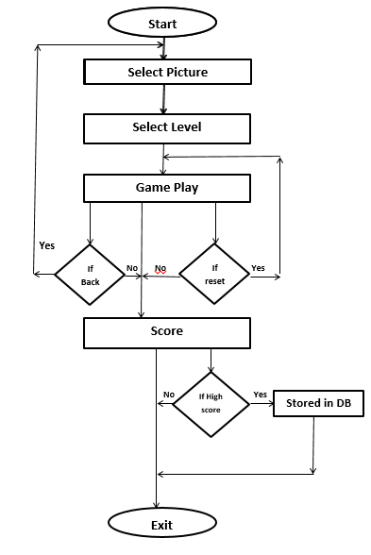

Sequence Diagram

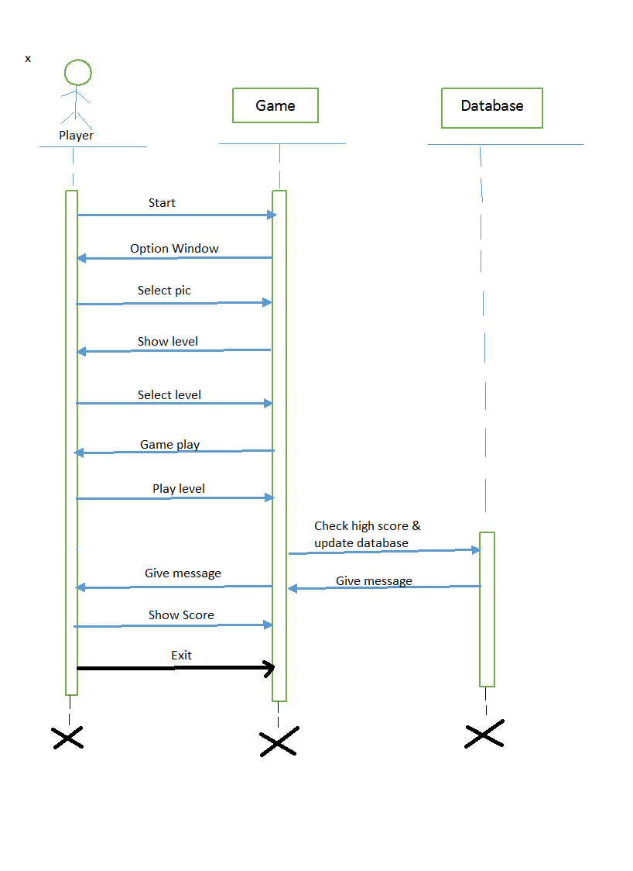

Activity Diagram

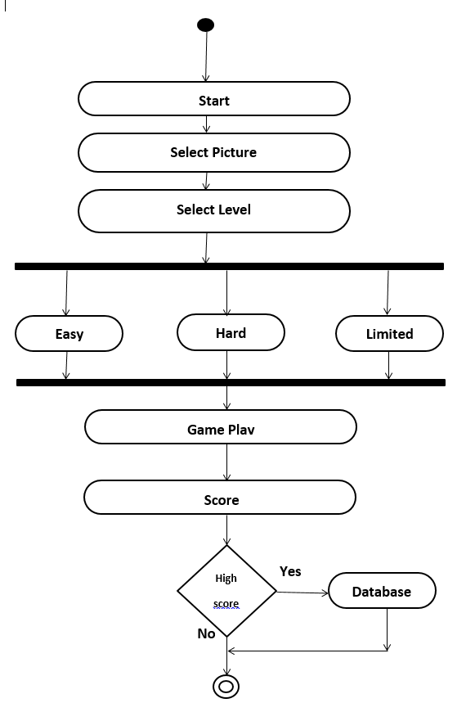

**Screen Shots**

**1.**

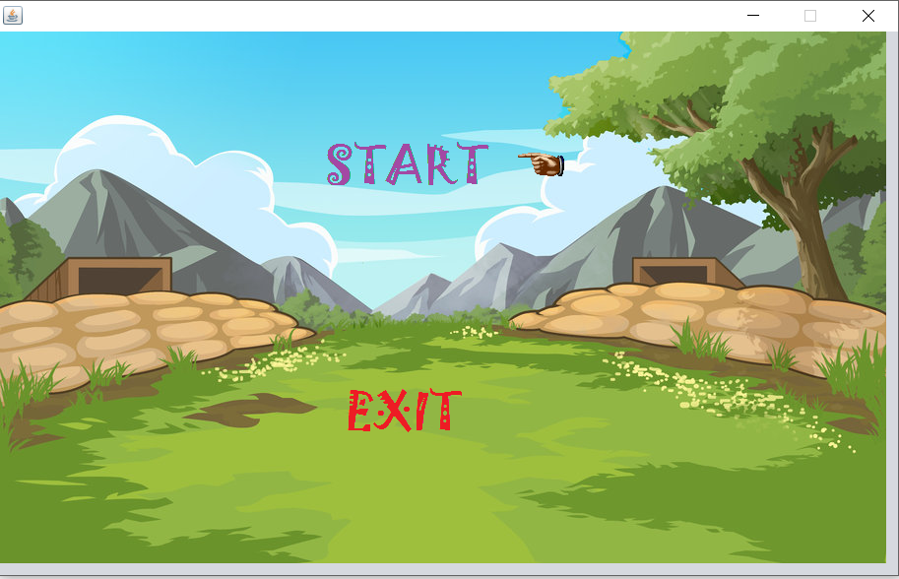

**2.**

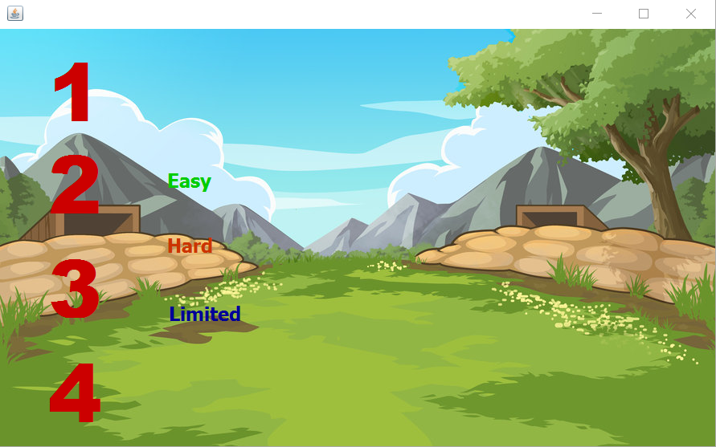

**3.**

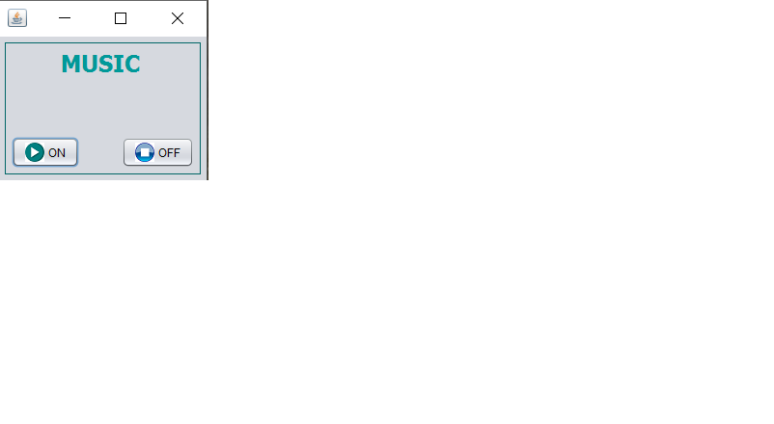

**4.**

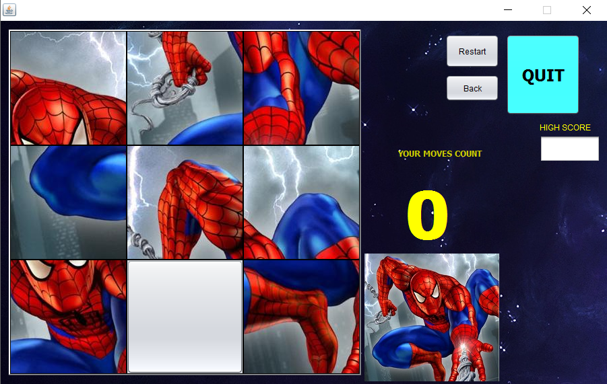

**5.**

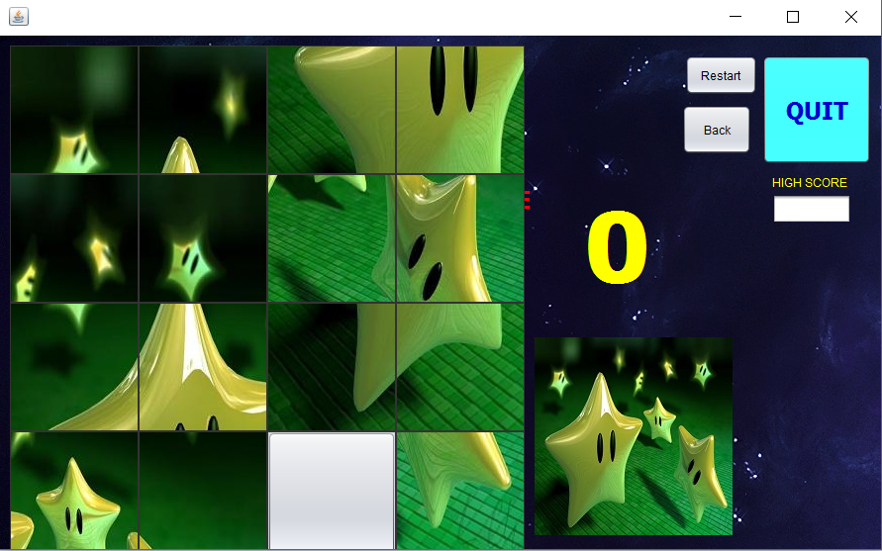

**6.**

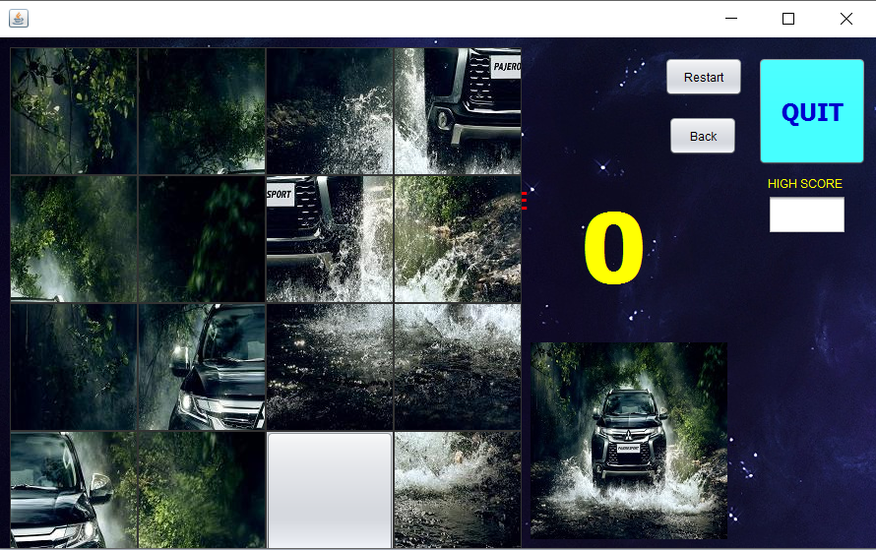

**7.**

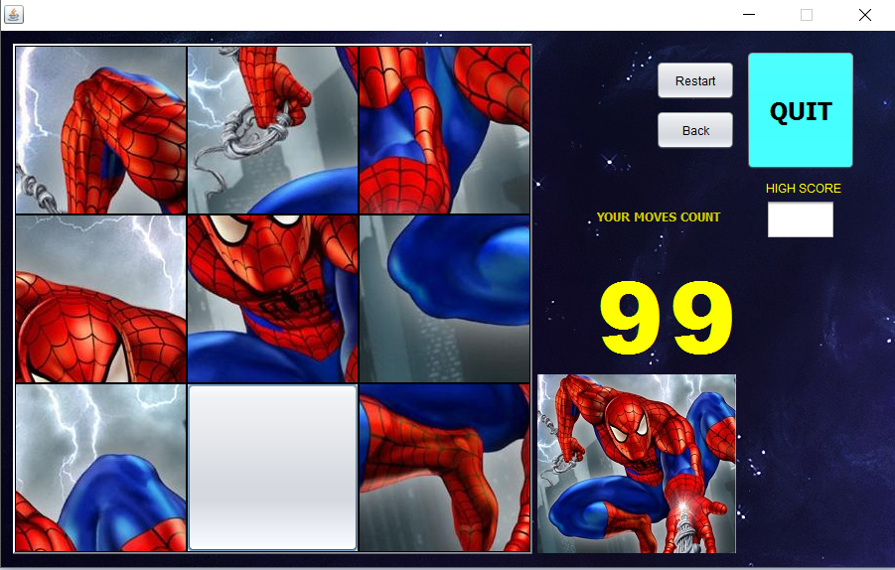

**8.**

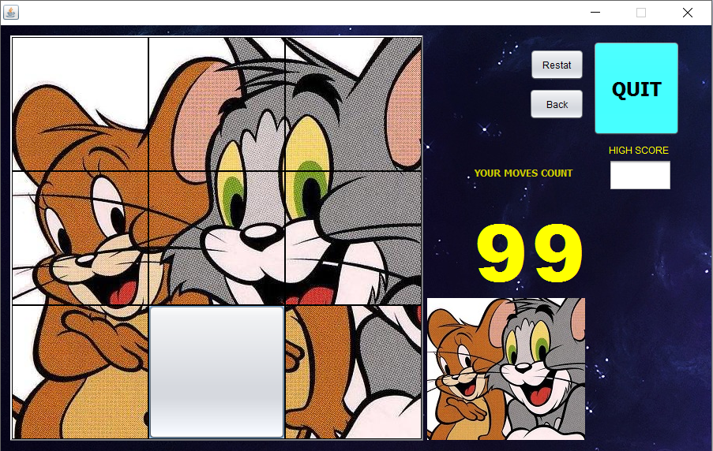

**9.**

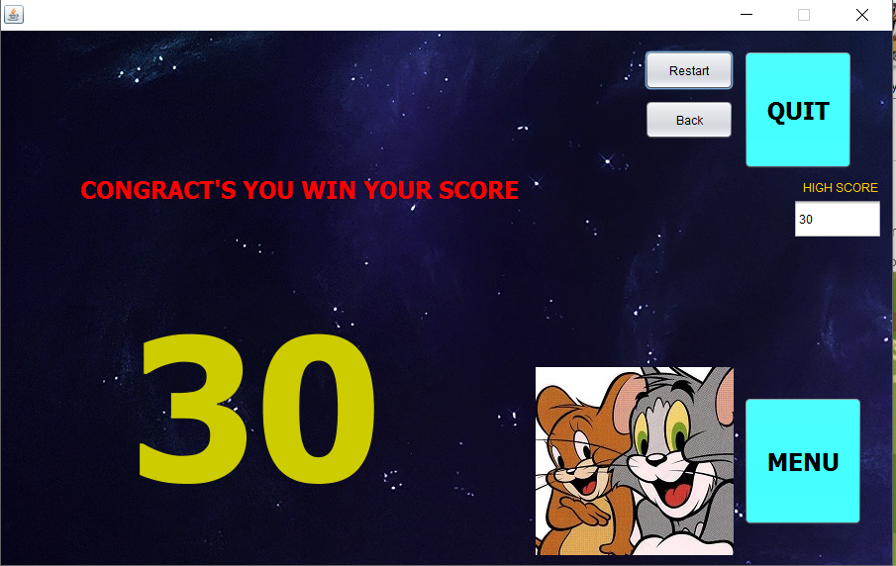

**Coding of important Screens**

**1. Image Matrix**

**public class jigsaw {**

**public void cut(){**

**try {**

**int row = 4;**

**int col = 4;**

**BufferedImage originalImgage = ImageIO.read(new File("D:/temp/tg.jpg"));**

**int tWidth = originalImgage.getWidth();**

**int tHeight = originalImgage.getHeight();**

**System.out.println("Image Dimension: " + tWidth + "x" + tHeight);**

**int eWidth = tWidth / col;**

**int eHeight = tHeight / row;**

**int x = 0;**

**int y = 0;**

**for (int i = 0; i < row; i++) {**

**y = 0;**

**for (int j = 0; j < col; j++) {**

**try {**

**System.out.println("creating piece: "+i+" "+j);**

**BufferedImage SubImgage = originalImgage.getSubimage(y, x, eWidth, eHeight);**

**File outputfile = new File("D:/temp/tg"+i+j+".jpg");**

**ImageIO.write(SubImgage, "jpg", outputfile);**

**y += eWidth;**

**} catch (Exception e) {**

**e.printStackTrace();**

**}**

**}**

**x += eHeight;**

**}**

**} catch (IOException e) {**

**e.printStackTrace();**

**}**

**}**

**public static void main(String[] args) {**

**jigsaw js=new jigsaw();**

**}**

**}**

1. **Optiopic**

**public class optiopics extends javax.swing.JFrame {**

**/\*\***

**\* Creates new form optiopics**

**\*/**

**public optiopics() {**

**initComponents();**

**}**

**Icon ic1=new ImageIcon(playeasy2.class.getResource("/spidermanpuzzle/tg.jpg"));**

**Icon ic2=new ImageIcon(playeasy2.class.getResource("/spidermanpuzzle/sm.jpg"));**

**Icon ic3=new ImageIcon(playmediumPajero.class.getResource("/PajeroPuzzleHard/pajero - copy.jpg"));**

**Icon ic4=new ImageIcon(playmediumStar.class.getResource("/StarPuzzleHard/stars - Copy.jpg"));**

**// String dcpath=System.getProperty("user.dir");**

**// String dc=dcpath.replace("\\", "/");**

**// String dcpath=dpath+"/puzzle";**

**/\*\***

**\* This method is called from within the constructor to initialize the form.**

**\* WARNING: Do NOT modify this code. The content of this method is always**

**\* regenerated by the Form Editor.**

**\*/**

**@SuppressWarnings("unchecked")**

**// <editor-fold defaultstate="collapsed" desc="Generated Code">**

**private void initComponents() {**

**jPanel1 = new javax.swing.JPanel();**

**jLabel1 = new javax.swing.JLabel();**

**jLabel2 = new javax.swing.JLabel();**

**jLabel3 = new javax.swing.JLabel();**

**jLabel4 = new javax.swing.JLabel();**

**jLabel5 = new javax.swing.JLabel();**

**jLabel6 = new javax.swing.JLabel();**

**jLabel7 = new javax.swing.JLabel();**

**jLabel10 = new javax.swing.JLabel();**

**jLabel9 = new javax.swing.JLabel();**

**setDefaultCloseOperation(javax.swing.WindowConstants.EXIT_ON_CLOSE);**

**jPanel1.setLayout(null);**

**jLabel1.setFont(new java.awt.Font("Arial Black", 1, 100)); // NOI18N**

**jLabel1.setForeground(new java.awt.Color(204, 0, 0));**

**jLabel1.setText("1");**

**jLabel1.addMouseListener(new java.awt.event.MouseAdapter() {**

**public void mouseClicked(java.awt.event.MouseEvent evt) {**

**jLabel1MouseClicked(evt);**

**}**

**public void mouseEntered(java.awt.event.MouseEvent evt) {**

**jLabel1MouseEntered(evt);**

**}**

**public void mouseExited(java.awt.event.MouseEvent evt) {**

**jLabel1MouseExited(evt);**

**}**

**});**

**jPanel1.add(jLabel1);**

**jLabel1.setBounds(60, 35, 80, 80);**

**jLabel2.setFont(new java.awt.Font("Arial Black", 1, 100)); // NOI18N**

**jLabel2.setForeground(new java.awt.Color(204, 0, 0));**

**jLabel2.setText("2");**

**jLabel2.addMouseListener(new java.awt.event.MouseAdapter() {**

**public void mouseClicked(java.awt.event.MouseEvent evt) {**

**jLabel2MouseClicked(evt);**

**}**

**public void mouseEntered(java.awt.event.MouseEvent evt) {**

**jLabel2MouseEntered(evt);**

**}**

**public void mouseExited(java.awt.event.MouseEvent evt) {**

**jLabel2MouseExited(evt);**

**}**

**});**

**jPanel1.add(jLabel2);**

**jLabel2.setBounds(60, 150, 80, 80);**

**jLabel3.setFont(new java.awt.Font("Arial Black", 1, 100)); // NOI18N**

**jLabel3.setForeground(new java.awt.Color(204, 0, 0));**

**jLabel3.setText("3");**

**jLabel3.addMouseListener(new java.awt.event.MouseAdapter() {**

**public void mouseClicked(java.awt.event.MouseEvent evt) {**

**jLabel3MouseClicked(evt);**

**}**

**public void mouseEntered(java.awt.event.MouseEvent evt) {**

**jLabel3MouseEntered(evt);**

**}**

**public void mouseExited(java.awt.event.MouseEvent evt) {**

**jLabel3MouseExited(evt);**

**}**

**});**

**jPanel1.add(jLabel3);**

**jLabel3.setBounds(60, 280, 80, 80);**

**jLabel4.setFont(new java.awt.Font("Arial Black", 1, 100)); // NOI18N**

**jLabel4.setForeground(new java.awt.Color(204, 0, 0));**

**jLabel4.setText("4");**

**jLabel4.addMouseListener(new java.awt.event.MouseAdapter() {**

**public void mouseClicked(java.awt.event.MouseEvent evt) {**

**jLabel4MouseClicked(evt);**

**}**

**public void mouseEntered(java.awt.event.MouseEvent evt) {**

**jLabel4MouseEntered(evt);**

**}**

**public void mouseExited(java.awt.event.MouseEvent evt) {**

**jLabel4MouseExited(evt);**

**}**

**});**

**jPanel1.add(jLabel4);**

**jLabel4.setBounds(60, 410, 80, 80);**

**jPanel1.add(jLabel5);**

**jLabel5.setBounds(361, 11, 520, 518);**

**jLabel6.setFont(new java.awt.Font("Tahoma", 1, 24)); // NOI18N**

**jLabel6.setForeground(new java.awt.Color(0, 204, 0));**

**jLabel6.setText("Easy");**

**jLabel6.addMouseListener(new java.awt.event.MouseAdapter() {**

**public void mouseClicked(java.awt.event.MouseEvent evt) {**

**jLabel6MouseClicked(evt);**

**}**

**});**

**jPanel1.add(jLabel6);**

**jLabel6.setBounds(208, 169, 120, 38);**

**jLabel7.setFont(new java.awt.Font("Tahoma", 1, 24)); // NOI18N**

**jLabel7.setForeground(new java.awt.Color(204, 51, 0));**

**jLabel7.setText("Hard");**

**jLabel7.addMouseListener(new java.awt.event.MouseAdapter() {**

**public void mouseClicked(java.awt.event.MouseEvent evt) {**

**jLabel7MouseClicked(evt);**

**}**

**});**

**jPanel1.add(jLabel7);**

**jLabel7.setBounds(208, 255, 120, 29);**

**jLabel10.setFont(new java.awt.Font("Tahoma", 1, 24)); // NOI18N**

**jLabel10.setForeground(new java.awt.Color(0, 0, 153));**

**jLabel10.setText("Limited");**

**jLabel10.addMouseListener(new java.awt.event.MouseAdapter() {**

**public void mouseClicked(java.awt.event.MouseEvent evt) {**

**jLabel10MouseClicked(evt);**

**}**

**});**

**jPanel1.add(jLabel10);**

**jLabel10.setBounds(210, 340, 120, 29);**

**jLabel9.setIcon(new javax.swing.ImageIcon(getClass().getResource("/image/bgmneu3.jpg"))); // NOI18N**

**jPanel1.add(jLabel9);**

**jLabel9.setBounds(0, 0, 890, 520);**

**javax.swing.GroupLayout layout = new javax.swing.GroupLayout(getContentPane());**

**getContentPane().setLayout(layout);**

**layout.setHorizontalGroup(**

**layout.createParallelGroup(javax.swing.GroupLayout.Alignment.LEADING)**

**.addComponent(jPanel1, javax.swing.GroupLayout.DEFAULT_SIZE, javax.swing.GroupLayout.DEFAULT_SIZE, Short.MAX_VALUE)**

**);**

**layout.setVerticalGroup(**

**layout.createParallelGroup(javax.swing.GroupLayout.Alignment.LEADING)**

**.addComponent(jPanel1, javax.swing.GroupLayout.DEFAULT_SIZE, javax.swing.GroupLayout.DEFAULT_SIZE, Short.MAX_VALUE)**

**);**

**setSize(new java.awt.Dimension(908, 567));**

**setLocationRelativeTo(null);**

**}// </editor-fold>**

**private void jLabel1MouseClicked(java.awt.event.MouseEvent evt) {**

**// TODO add your handling code here:**

**// String path = "D:\temp\tg.jpg";**

**// imagematirx im = new imagematirx(path);**

**jLabel5.setIcon(ic2);**

**}**

**private void jLabel2MouseClicked(java.awt.event.MouseEvent evt) {**

**// TODO add your handling code here:**

**jLabel5.setIcon(ic1);**

**}**

**private void jLabel3MouseClicked(java.awt.event.MouseEvent evt) {**

**// TODO add your handling code here:**

**jLabel5.setIcon(ic3);**

**}**

**private void jLabel4MouseClicked(java.awt.event.MouseEvent evt) {**

**jLabel5.setIcon(ic4);**

**// TODO add your handling code here:**

**}**

**private void jLabel1MouseEntered(java.awt.event.MouseEvent evt) {**

**// TODO add your handling code here:**

**jLabel5.setIcon(ic2);**

**}**

**private void jLabel1MouseExited(java.awt.event.MouseEvent evt) {**

**// TODO add your handling code here:**

**//jLabel5.setIcon(null);**

**}**

**private void jLabel2MouseEntered(java.awt.event.MouseEvent evt) {**

**// TODO add your handling code here:**

**jLabel5.setIcon(ic1);**

**}**

**private void jLabel2MouseExited(java.awt.event.MouseEvent evt) {**

**// TODO add your handling code here:**

**//jLabel5.setIcon(null);**

**}**

**private void jLabel6MouseClicked(java.awt.event.MouseEvent evt) {**

**// TODO add your handling code here:**

**if(jLabel5.getIcon()==ic3){**

**playeasyPajero pe = new playeasyPajero();**

**pe.setVisible(true);**

**this.dispose();**

**}**

**else if(jLabel5.getIcon()==ic2){**

**playeasy1 pe1=new playeasy1();**

**pe1.setVisible(true);**

**this.dispose();**

**}**

**else if(jLabel5.getIcon()==ic1){**

**playeasy2 pe1=new playeasy2();**

**pe1.setVisible(true);**

**this.dispose();**

**}**

**else if(jLabel5.getIcon()==ic4){**

**playeasyStar pe1=new playeasyStar();**

**pe1.setVisible(true);**

**this.dispose();**

**}**

**}**

**private void jLabel7MouseClicked(java.awt.event.MouseEvent evt) {**

**// TODO add your handling code here:**

**if(jLabel5.getIcon()==ic3){**

**playmediumPajero pe = new playmediumPajero();**

**pe.setVisible(true);**

**this.dispose();**

**}**

**else if(jLabel5.getIcon()==ic2){**

**playmediumSpiderman pe1=new playmediumSpiderman();**

**pe1.setVisible(true);**

**this.dispose();**

**}**

**else if(jLabel5.getIcon()==ic1){**

**playmediumTomJerry pe1=new playmediumTomJerry();**

**pe1.setVisible(true);**

**this.dispose();**

**}**

**else if(jLabel5.getIcon()==ic4){**

**playmediumStar pe1=new playmediumStar();**

**pe1.setVisible(true);**

**this.dispose();**

**}**

**}**

**private void jLabel3MouseEntered(java.awt.event.MouseEvent evt) {**

**// TODO add your handling code here:**

**jLabel5.setIcon(ic3);**

**}**

**private void jLabel3MouseExited(java.awt.event.MouseEvent evt) {**

**//jLabel5.setIcon(null);**

**// TODO add your handling code here:**

**}**

**private void jLabel4MouseEntered(java.awt.event.MouseEvent evt) {**

**jLabel5.setIcon(ic4);**

**// TODO add your handling code here:**

**}**

**private void jLabel4MouseExited(java.awt.event.MouseEvent evt) {**

**// TODO add your handling code here:**

**//jLabel5.setIcon(null);**

**}**

**private void jLabel10MouseClicked(java.awt.event.MouseEvent evt) {**

**// TODO add your handling code here:**

**if(jLabel5.getIcon()==ic2){**

**PlayLimitedSpiderman sp = new PlayLimitedSpiderman();**

**sp.setVisible(true);**

**this.dispose();**

**}else**

**if(jLabel5.getIcon()==ic3){**

**PlayLimitedPajero per = new PlayLimitedPajero();**

**per.setVisible(true);**

**this.dispose();**

**}else**

**if(jLabel5.getIcon()==ic4){**

**PlayLimitedStars str = new PlayLimitedStars();**

**str.setVisible(true);**

**this.dispose();**

**}else**

**if(jLabel5.getIcon()==ic1){**

**PlayLimitedTomJerry tj = new PlayLimitedTomJerry();**

**tj.setVisible(true);**

**this.dispose();**

**}**

**}**

**/\*\***

**\* @param args the command line arguments**

**\*/**

**public static void main(String args[]) {**

**/* Set the Nimbus look and feel */**

**//<editor-fold defaultstate="collapsed" desc=" Look and feel setting code (optional) ">**

**/* If Nimbus (introduced in Java SE 6) is not available, stay with the default look and feel.**

**\* For details see http://download.oracle.com/javase/tutorial/uiswing/lookandfeel/plaf.html**

**\*/**

**try {**

**for (javax.swing.UIManager.LookAndFeelInfo info : javax.swing.UIManager.getInstalledLookAndFeels()) {**

**if ("Nimbus".equals(info.getName())) {**

**javax.swing.UIManager.setLookAndFeel(info.getClassName());**

**break;**

**}**

**}**

**} catch (ClassNotFoundException ex) {**

**java.util.logging.Logger.getLogger(optiopics.class.getName()).log(java.util.logging.Level.SEVERE, null, ex);**

**} catch (InstantiationException ex) {**

**java.util.logging.Logger.getLogger(optiopics.class.getName()).log(java.util.logging.Level.SEVERE, null, ex);**

**} catch (IllegalAccessException ex) {**

**java.util.logging.Logger.getLogger(optiopics.class.getName()).log(java.util.logging.Level.SEVERE, null, ex);**

**} catch (javax.swing.UnsupportedLookAndFeelException ex) {**

**java.util.logging.Logger.getLogger(optiopics.class.getName()).log(java.util.logging.Level.SEVERE, null, ex);**

**}**

**//</editor-fold>**

**/* Create and display the form */**

**java.awt.EventQueue.invokeLater(new Runnable() {**

**public void run() {**

**new optiopics().setVisible(true);**

**}**

**});**

**}**

**// Variables declaration - do not modify**

**private javax.swing.JLabel jLabel1;**

**private javax.swing.JLabel jLabel10;**

**private javax.swing.JLabel jLabel2;**

**private javax.swing.JLabel jLabel3;**

**private javax.swing.JLabel jLabel4;**

**private javax.swing.JLabel jLabel5;**

**private javax.swing.JLabel jLabel6;**

**private javax.swing.JLabel jLabel7;**

**private javax.swing.JLabel jLabel9;**

**private javax.swing.JPanel jPanel1;**

**// End of variables declaration**

**}**

1. **PlayEasyPajero**

**public class playeasyPajero extends javax.swing.JFrame {**

**public static int cnt1;**

**static int x=cnt1;**

**/\*\***

**\* Creates new form playeasy1**

**\*/**

**public playeasyPajero() {**

**initComponents();**

**this.setResizable(false);**

**pack();**

**}**

**int cnt=0;**

**public void check(){**

**if(jButton1.getIcon()==ic1 && jButton2.getIcon()==ic2 && jButton3.getIcon()==ic3 &&**

**jButton4.getIcon()==ic4 && jButton5.getIcon()==ic5 && jButton6.getIcon()==ic6 &&**

**jButton7.getIcon()==ic7 && jButton8.getIcon()==ic8 && jButton9.getIcon()==null ){**

**// win w= new win();**

**// w.setVisible(true);**

**// this.setVisible(false);**

**try {**

**Thread.sleep(1000);**

**} catch (InterruptedException ex) {**

**Logger.getLogger(MYproject.class.getName()).log(Level.SEVERE, null, ex);**

**}**

**jLabel5.setVisible(false);**

**jPanel2.setVisible(false);**

**jButton10.setVisible(true);**

**jButton11.setVisible(true);**

**jLabel3.setVisible(true);**

**jLabel4.setVisible(true);**

**jLabel2.setVisible(false);**

**String count=Integer.toString(cnt);**

**jLabel3.setText(count);**

**try {**

**// TODO add your handling code here:**

**JOptionPane.showMessageDialog(null,"Your Current Score is:"+cnt);**

**int z=jj();**

**x=cnt1;**

**if(x<z){**

**kk(x);**

**jj();**

**} } catch (Exception ex) {**

**//Logger.getLogger(TomJerryHighScores.class.getName()).log(Level.SEVERE, null, ex);**

**}**

**}**

**}**

**public void count(){**

**String count=Integer.toString(cnt);**

**jLabel2.setText(count);**

**}**

**// String dp=System.getProperty("user.dir")+"/puzzle";**

**// String dcp=dp.replaceAll("\\", "/");**

**Icon ic1=new ImageIcon(playeasyPajero.class.getResource("/PajeroPuzzleHard/easycuth00.jpg"));**

**Icon ic2=new ImageIcon(playeasyPajero.class.getResource("/PajeroPuzzleHard/easycuth01.jpg"));**

**Icon ic3=new ImageIcon(playeasyPajero.class.getResource("/PajeroPuzzleHard/easycuth02.jpg"));**

**Icon ic4=new ImageIcon(playeasyPajero.class.getResource("/PajeroPuzzleHard/easycuth10.jpg"));**

**Icon ic5=new ImageIcon(playeasyPajero.class.getResource("/PajeroPuzzleHard/easycuth11.jpg"));**

**Icon ic6=new ImageIcon(playeasyPajero.class.getResource("/PajeroPuzzleHard/easycuth12.jpg"));**

**Icon ic7=new ImageIcon(playeasyPajero.class.getResource("/PajeroPuzzleHard/easycuth20.jpg"));**

**Icon ic8=new ImageIcon(playeasyPajero.class.getResource("/PajeroPuzzleHard/easycuth21.jpg"));**

**Icon ic9=new ImageIcon(playeasyPajero.class.getResource("/PajeroPuzzleHard/easycuth22.jpg"));**

**/\*\***

**\* This method is called from within the constructor to initialize the form.**

**\* WARNING: Do NOT modify this code. The content of this method is always**

**\* regenerated by the Form Editor.**

**\*/**

**@SuppressWarnings("unchecked")**

**// <editor-fold defaultstate="collapsed" desc="Generated Code">**

**private void initComponents() {**

**jLabel1 = new javax.swing.JLabel();**

**jPanel1 = new javax.swing.JPanel();**

**jButton13 = new javax.swing.JButton();**

**jButton12 = new javax.swing.JButton();**

**jLabel7 = new javax.swing.JLabel();**

**jTextField1 = new javax.swing.JTextField();**

**jLabel8 = new javax.swing.JLabel();**

**jPanel2 = new javax.swing.JPanel();**

**jButton1 = new javax.swing.JButton();**

**jButton2 = new javax.swing.JButton();**

**jButton3 = new javax.swing.JButton();**

**jButton4 = new javax.swing.JButton();**

**jButton5 = new javax.swing.JButton();**

**jButton6 = new javax.swing.JButton();**

**jButton7 = new javax.swing.JButton();**

**jButton8 = new javax.swing.JButton();**

**jButton9 = new javax.swing.JButton();**

**jLabel2 = new javax.swing.JLabel();**

**jLabel3 = new javax.swing.JLabel();**

**jLabel4 = new javax.swing.JLabel();**

**jButton10 = new javax.swing.JButton();**

**jButton11 = new javax.swing.JButton();**

**jLabel5 = new javax.swing.JLabel();**

**jLabel6 = new javax.swing.JLabel();**

**jLabel1.setText("jLabel1");**

**setDefaultCloseOperation(javax.swing.WindowConstants.EXIT_ON_CLOSE);**

**setCursor(new java.awt.Cursor(java.awt.Cursor.DEFAULT_CURSOR));**

**jPanel1.setBackground(new java.awt.Color(51, 51, 51));**

**jPanel1.setBorder(javax.swing.BorderFactory.createBevelBorder(javax.swing.border.BevelBorder.RAISED));**

**jPanel1.setLayout(null);**

**jButton13.setText("Back");**

**jButton13.addActionListener(new java.awt.event.ActionListener() {**

**public void actionPerformed(java.awt.event.ActionEvent evt) {**

**jButton13ActionPerformed(evt);**

**}**

**});**

**jPanel1.add(jButton13);**

**jButton13.setBounds(650, 80, 90, 40);**

**jButton12.setText("Restart");**

**jButton12.addActionListener(new java.awt.event.ActionListener() {**

**public void actionPerformed(java.awt.event.ActionEvent evt) {**

**jButton12ActionPerformed(evt);**

**}**

**});**

**jPanel1.add(jButton12);**

**jButton12.setBounds(650, 30, 90, 40);**

**jLabel7.setIcon(new javax.swing.ImageIcon("C:\\Users\\Atharva\\Documents\\pajero - Copy - Copy.jpg")); // NOI18N**

**jLabel7.setText("jLabel7");**

**jPanel1.add(jLabel7);**

**jLabel7.setBounds(541, 340, 190, 180);**

**jTextField1.setEditable(false);**

**jTextField1.addActionListener(new java.awt.event.ActionListener() {**

**public void actionPerformed(java.awt.event.ActionEvent evt) {**

**jTextField1ActionPerformed(evt);**

**}**

**});**

**jPanel1.add(jTextField1);**

**jTextField1.setBounds(790, 170, 100, 40);**

**jLabel8.setForeground(new java.awt.Color(255, 204, 0));**

**jLabel8.setText("HIGH SCORE");**

**jPanel1.add(jLabel8);**

**jLabel8.setBounds(790, 150, 80, 16);**

**jPanel2.setBorder(javax.swing.BorderFactory.createBevelBorder(javax.swing.border.BevelBorder.RAISED));**

**jPanel2.setLayout(new java.awt.GridLayout(3, 3));**

**jButton1.setIcon(ic2);**

**jButton1.setBorder(javax.swing.BorderFactory.createLineBorder(new java.awt.Color(0, 0, 0)));**

**jButton1.setPreferredSize(new java.awt.Dimension(173, 173));**

**jButton1.addActionListener(new java.awt.event.ActionListener() {**

**public void actionPerformed(java.awt.event.ActionEvent evt) {**

**jButton1ActionPerformed(evt);**

**}**

**});**

**jPanel2.add(jButton1);**

**jButton2.setIcon(ic4);**

**jButton2.setBorder(javax.swing.BorderFactory.createLineBorder(new java.awt.Color(0, 0, 0)));**

**jButton2.setPreferredSize(new java.awt.Dimension(173, 173));**

**jButton2.addActionListener(new java.awt.event.ActionListener() {**

**public void actionPerformed(java.awt.event.ActionEvent evt) {**

**jButton2ActionPerformed(evt);**

**}**

**});**

**jPanel2.add(jButton2);**

**jButton3.setIcon(ic6);**

**jButton3.setBorder(javax.swing.BorderFactory.createLineBorder(new java.awt.Color(0, 0, 0)));**

**jButton3.setPreferredSize(new java.awt.Dimension(173, 173));**

**jButton3.addActionListener(new java.awt.event.ActionListener() {**

**public void actionPerformed(java.awt.event.ActionEvent evt) {**

**jButton3ActionPerformed(evt);**

**}**

**});**

**jPanel2.add(jButton3);**

**jButton4.setIcon(ic7);**

**jButton4.setBorder(javax.swing.BorderFactory.createLineBorder(new java.awt.Color(0, 0, 0)));**

**jButton4.setPreferredSize(new java.awt.Dimension(173, 173));**

**jButton4.addActionListener(new java.awt.event.ActionListener() {**

**public void actionPerformed(java.awt.event.ActionEvent evt) {**

**jButton4ActionPerformed(evt);**

**}**

**});**

**jPanel2.add(jButton4);**

**jButton5.setIcon(ic1);**

**jButton5.setBorder(javax.swing.BorderFactory.createLineBorder(new java.awt.Color(0, 0, 0)));**

**jButton5.setPreferredSize(new java.awt.Dimension(173, 173));**

**jButton5.addActionListener(new java.awt.event.ActionListener() {**

**public void actionPerformed(java.awt.event.ActionEvent evt) {**

**jButton5ActionPerformed(evt);**

**}**

**});**

**jPanel2.add(jButton5);**

**jButton6.setIcon(ic3);**

**jButton6.setBorder(javax.swing.BorderFactory.createLineBorder(new java.awt.Color(0, 0, 0)));**

**jButton6.setPreferredSize(new java.awt.Dimension(173, 173));**

**jButton6.addActionListener(new java.awt.event.ActionListener() {**

**public void actionPerformed(java.awt.event.ActionEvent evt) {**

**jButton6ActionPerformed(evt);**

**}**

**});**

**jPanel2.add(jButton6);**

**jButton7.setIcon(ic5);**

**jButton7.setBorder(javax.swing.BorderFactory.createLineBorder(new java.awt.Color(0, 0, 0)));**

**jButton7.setPreferredSize(new java.awt.Dimension(173, 173));**

**jButton7.addActionListener(new java.awt.event.ActionListener() {**

**public void actionPerformed(java.awt.event.ActionEvent evt) {**

**jButton7ActionPerformed(evt);**

**}**

**});**

**jPanel2.add(jButton7);**

**jButton8.setFont(new java.awt.Font("Tahoma", 1, 24)); // NOI18N**

**jButton8.setForeground(new java.awt.Color(0, 0, 204));**

**jButton8.setIcon(null);**

**jButton8.setBorder(javax.swing.BorderFactory.createLineBorder(new java.awt.Color(0, 0, 0)));**

**jButton8.setPreferredSize(new java.awt.Dimension(173, 173));**

**jButton8.addActionListener(new java.awt.event.ActionListener() {**

**public void actionPerformed(java.awt.event.ActionEvent evt) {**

**jButton8ActionPerformed(evt);**

**}**

**});**

**jPanel2.add(jButton8);**

**jButton9.setBorder(javax.swing.BorderFactory.createLineBorder(new java.awt.Color(0, 0, 0)));**

**jButton9.setIcon(ic8);**

**jButton9.setPreferredSize(new java.awt.Dimension(173, 173));**

**jButton9.addActionListener(new java.awt.event.ActionListener() {**

**public void actionPerformed(java.awt.event.ActionEvent evt) {**

**jButton9ActionPerformed(evt);**

**}**

**});**

**jPanel2.add(jButton9);**

**jPanel1.add(jPanel2);**

**jPanel2.setBounds(12, 13, 523, 514);**

**jLabel2.setFont(new java.awt.Font("Arial Black", 1, 100)); // NOI18N**

**jLabel2.setForeground(new java.awt.Color(255, 255, 0));**

**jLabel2.setText("0");**

**jLabel2.addMouseListener(new java.awt.event.MouseAdapter() {**

**public void mouseEntered(java.awt.event.MouseEvent evt) {**

**jLabel2MouseEntered(evt);**

**}**

**});**

**jPanel1.add(jLabel2);**

**jLabel2.setBounds(600, 210, 230, 150);**

**jLabel3.setFont(new java.awt.Font("Tahoma", 1, 200)); // NOI18N**

**jLabel3.setForeground(new java.awt.Color(204, 204, 0));**

**jLabel3.setVisible(false);**

**jLabel3.setText(" 000");**

**jPanel1.add(jLabel3);**

**jLabel3.setBounds(130, 270, 510, 210);**

**jLabel4.setFont(new java.awt.Font("Tahoma", 1, 24)); // NOI18N**

**jLabel4.setVisible(false);**

**jLabel4.setForeground(new java.awt.Color(255, 0, 0));**

**jLabel4.setText("CONGRACT'S YOU WIN YOUR SCORE");**

**jPanel1.add(jLabel4);**

**jLabel4.setBounds(80, 130, 550, 60);**

**jButton10.setBackground(new java.awt.Color(51, 255, 255));**

**jButton10.setFont(new java.awt.Font("Tahoma", 1, 24)); // NOI18N**

**jButton10.setText("QUIT");**

**jButton10.addActionListener(new java.awt.event.ActionListener() {**

**public void actionPerformed(java.awt.event.ActionEvent evt) {**

**jButton10ActionPerformed(evt);**

**}**

**});**

**jPanel1.add(jButton10);**

**jButton10.setBounds(750, 20, 110, 120);**

**jButton11.setBackground(new java.awt.Color(51, 255, 255));**

**jButton11.setFont(new java.awt.Font("Tahoma", 1, 24)); // NOI18N**

**jButton11.setText("MENU");**

**jButton11.setVisible(false);**

**jButton11.addActionListener(new java.awt.event.ActionListener() {**

**public void actionPerformed(java.awt.event.ActionEvent evt) {**

**jButton11ActionPerformed(evt);**

**}**

**});**

**jPanel1.add(jButton11);**

**jButton11.setBounds(750, 370, 120, 130);**

**jLabel5.setFont(new java.awt.Font("Tahoma", 1, 12)); // NOI18N**

**jLabel5.setForeground(new java.awt.Color(204, 204, 0));**

**jLabel5.setText("YOUR MOVES COUNT");**

**jPanel1.add(jLabel5);**

**jLabel5.setBounds(580, 190, 200, 14);**

**jLabel6.setIcon(new javax.swing.ImageIcon(getClass().getResource("/image/sidebg1.jpg"))); // NOI18N**

**jPanel1.add(jLabel6);**

**jLabel6.setBounds(0, 0, 900, 540);**

**javax.swing.GroupLayout layout = new javax.swing.GroupLayout(getContentPane());**

**getContentPane().setLayout(layout);**

**layout.setHorizontalGroup(**

**layout.createParallelGroup(javax.swing.GroupLayout.Alignment.LEADING)**

**.addComponent(jPanel1, javax.swing.GroupLayout.PREFERRED_SIZE, 900, javax.swing.GroupLayout.PREFERRED_SIZE)**

**);**

**layout.setVerticalGroup(**

**layout.createParallelGroup(javax.swing.GroupLayout.Alignment.LEADING)**

**.addComponent(jPanel1, javax.swing.GroupLayout.PREFERRED_SIZE, 540, javax.swing.GroupLayout.PREFERRED_SIZE)**

**);**

**setSize(new java.awt.Dimension(918, 587));**

**setLocationRelativeTo(null);**

**}// </editor-fold>**

**private void jButton5ActionPerformed(java.awt.event.ActionEvent evt) {**

**// TODO add your handling code here:**

**if(jButton2.getIcon()==null){**

**Icon temp = jButton5.getIcon();**

**jButton2.setIcon(temp);**

**jButton5.setIcon(null);**

**}**

**else if(jButton4.getIcon()==null){**

**Icon temp = jButton5.getIcon();**

**jButton4.setIcon(temp);**

**jButton5.setIcon(null);**

**}**

**else if(jButton6.getIcon()==null){**

**Icon temp = jButton5.getIcon();**

**jButton6.setIcon(temp);**

**jButton5.setIcon(null);**

**}**

**else if(jButton8.getIcon()==null){**

**Icon temp = jButton5.getIcon();**

**jButton8.setIcon(temp);**

**jButton5.setIcon(null);**

**}**

**count();**

**check();**

**cnt++; try {**

**sound s = new sound();**

**} catch (LineUnavailableException ex) {**

**Logger.getLogger(playeasy1.class.getName()).log(Level.SEVERE, null, ex);**

**}**

**}**

**private void jButton1ActionPerformed(java.awt.event.ActionEvent evt) {**

**// TODO add your handling code here:**

**if(jButton2.getIcon()==null){**

**Icon temp = jButton1.getIcon();**

**jButton2.setIcon(temp);**

**jButton1.setIcon(null);**

**}**

**else if(jButton4.getIcon()==null){**

**Icon temp = jButton1.getIcon();**

**jButton4.setIcon(temp);**

**jButton1.setIcon(null);**

**}**

**count(); check(); cnt++; try {**

**sound s = new sound();**

**} catch (LineUnavailableException ex) {**

**Logger.getLogger(playeasy1.class.getName()).log(Level.SEVERE, null, ex);**

**}**

**}**

**private void jButton2ActionPerformed(java.awt.event.ActionEvent evt) {**

**// TODO add your handling code here:**

**if(jButton1.getIcon()==null){**

**Icon temp = jButton2.getIcon();**

**jButton1.setIcon(temp);**

**jButton2.setIcon(null);**

**}**

**else if(jButton3.getIcon()==null){**

**Icon temp = jButton2.getIcon();**

**jButton3.setIcon(temp);**

**jButton2.setIcon(null);**

**}**

**else if(jButton5.getIcon()==null){**

**Icon temp = jButton2.getIcon();**

**jButton5.setIcon(temp);**

**jButton2.setIcon(null);**

**}**

**count(); check(); cnt++; try {**

**sound s = new sound();**

**} catch (LineUnavailableException ex) {**

**Logger.getLogger(playeasy1.class.getName()).log(Level.SEVERE, null, ex);**

**}**

**}**

**private void jButton3ActionPerformed(java.awt.event.ActionEvent evt) {**

**// TODO add your handling code here:**

**if(jButton2.getIcon()==null){**

**Icon temp = jButton3.getIcon();**

**jButton2.setIcon(temp);**

**jButton3.setIcon(null);**

**}**

**else if(jButton6.getIcon()==null){**

**Icon temp = jButton3.getIcon();**

**jButton6.setIcon(temp);**

**jButton3.setIcon(null);**

**}**

**count(); check(); cnt++; try {**

**sound s = new sound();**

**} catch (LineUnavailableException ex) {**

**Logger.getLogger(playeasy1.class.getName()).log(Level.SEVERE, null, ex);**

**}**

**}**

**private void jButton4ActionPerformed(java.awt.event.ActionEvent evt) {**

**// TODO add your handling code here:**

**if(jButton1.getIcon()==null){**

**Icon temp = jButton4.getIcon();**

**jButton1.setIcon(temp);**

**jButton4.setIcon(null);**

**}**

**else if(jButton5.getIcon()==null){**

**Icon temp = jButton4.getIcon();**

**jButton5.setIcon(temp);**

**jButton4.setIcon(null);**

**}**

**else if(jButton7.getIcon()==null){**

**Icon temp = jButton4.getIcon();**

**jButton7.setIcon(temp);**

**jButton4.setIcon(null);**

**}**

**count(); check(); cnt++; try {**

**sound s = new sound();**

**} catch (LineUnavailableException ex) {**

**Logger.getLogger(playeasy1.class.getName()).log(Level.SEVERE, null, ex);**

**}**

**}**

**private void jButton6ActionPerformed(java.awt.event.ActionEvent evt) {**

**// TODO add your handling code here:**

**if(jButton9.getIcon()==null){**

**Icon temp = jButton6.getIcon();**

**jButton9.setIcon(temp);**

**jButton6.setIcon(null);**

**}**

**else if(jButton3.getIcon()==null){**

**Icon temp = jButton6.getIcon();**

**jButton3.setIcon(temp);**

**jButton6.setIcon(null);**

**}**

**else if(jButton5.getIcon()==null){**

**Icon temp = jButton6.getIcon();**

**jButton5.setIcon(temp);**

**jButton6.setIcon(null);**

**}**

**count(); check(); cnt++; try {**

**sound s = new sound();**

**} catch (LineUnavailableException ex) {**

**Logger.getLogger(playeasy1.class.getName()).log(Level.SEVERE, null, ex);**

**}**

**}**

**private void jButton7ActionPerformed(java.awt.event.ActionEvent evt) {**

**// TODO add your handling code here:**

**if(jButton4.getIcon()==null){**

**Icon temp = jButton7.getIcon();**

**jButton4.setIcon(temp);**

**jButton7.setIcon(null);**

**}**

**else if(jButton8.getIcon()==null){**

**Icon temp = jButton7.getIcon();**

**jButton8.setIcon(temp);**

**jButton7.setIcon(null);**

**}**

**count(); check(); cnt++; try {**

**sound s = new sound();**

**} catch (LineUnavailableException ex) {**

**Logger.getLogger(playeasy1.class.getName()).log(Level.SEVERE, null, ex);**

**}**

**}**

**private void jButton8ActionPerformed(java.awt.event.ActionEvent evt) {**

**// TODO add your handling code here:**

**if(jButton5.getIcon()==null){**

**Icon temp = jButton8.getIcon();**

**jButton5.setIcon(temp);**

**jButton8.setIcon(null);**

**}**

**else if(jButton7.getIcon()==null){**

**Icon temp = jButton8.getIcon();**

**jButton7.setIcon(temp);**

**jButton8.setIcon(null);**

**}**

**else if(jButton9.getIcon()==null){**

**Icon temp = jButton8.getIcon();**

**jButton9.setIcon(temp);**

**jButton8.setIcon(null);**

**}**

**count(); check(); cnt++; try {**

**sound s = new sound();**

**} catch (LineUnavailableException ex) {**

**Logger.getLogger(playeasy1.class.getName()).log(Level.SEVERE, null, ex);**

**}**

**}**

**private void jButton9ActionPerformed(java.awt.event.ActionEvent evt) {**

**// TODO add your handling code here:**

**if(jButton6.getIcon()==null){**

**Icon temp = jButton9.getIcon();**

**jButton6.setIcon(temp);**

**jButton9.setIcon(null);**

**}**

**else if(jButton8.getIcon()==null){**

**Icon temp = jButton9.getIcon();**

**jButton8.setIcon(temp);**

**jButton9.setIcon(null);**

**}**

**count(); check(); cnt++; try {**

**sound s = new sound();**

**} catch (LineUnavailableException ex) {**

**Logger.getLogger(playeasy1.class.getName()).log(Level.SEVERE, null, ex);**

**}**

**}**

**private void jLabel2MouseEntered(java.awt.event.MouseEvent evt) {**

**// TODO add your handling code here:**

**jLabel1.setForeground(new java.awt.Color(255, 255, 2));**

**}**

**private void jButton10ActionPerformed(java.awt.event.ActionEvent evt) {**

**// TODO add your handling code here:**

**this.dispose();**

**}**

**private void jButton11ActionPerformed(java.awt.event.ActionEvent evt) {**

**// TODO add your handling code here:**

**try {**

**Thread.sleep(3*1000);**

**} catch (InterruptedException ex) {**

**Logger.getLogger(MYproject.class.getName()).log(Level.SEVERE, null, ex);**

**}**

**MYproject mp = new MYproject();**

**mp.setVisible(true);**

**this.dispose();**

**}**

**private void jButton12ActionPerformed(java.awt.event.ActionEvent evt) {**

**// TODO add your handling code here:**

**cnt=0;**

**String count=Integer.toString(cnt);**

**jLabel2.setText(count);**

**jButton1.setIcon(ic1);**

**jButton2.setIcon(ic2);**

**jButton3.setIcon(ic9);**

**jButton4.setIcon(ic6);**

**jButton5.setIcon(ic3);**

**jButton6.setIcon(ic4);**

**jButton7.setIcon(ic7);**

**jButton8.setIcon(ic5);**

**jButton9.setIcon(null);**

**}**

**private void jButton13ActionPerformed(java.awt.event.ActionEvent evt) {**

**// TODO add your handling code here:**

**setVisible(false);**

**optiopics mp=new optiopics();**

**mp.setVisible(true);**

**}**

**public void kk(int cnt1) throws Exception{**

**int x=cnt1;**

**Connection con=DBconnect.getConnection();**

**Statement st=con.createStatement();**

**int rs=st.executeUpdate("update pajero_high set easy="+x);**

**JOptionPane.showMessageDialog(null,"Congratulations You beat the high score");**

**//rs.next();**

**// x=rs.getInt(1);**

**//rs.close();**

**st.close();**

**con.close();**

**}**

**public int jj() throws Exception**

**{**

**int x;**

**Connection con=DBconnect.getConnection();**

**Statement st=con.createStatement();**

**ResultSet rs=st.executeQuery("select * from pajero_high");**

**rs.next();**

**x=rs.getInt(1);**

**jTextField1.setText(rs.getString(1));**

**rs.close();**

**st.close();**

**con.close();**

**return x;**

**}**

**private void jTextField1ActionPerformed(java.awt.event.ActionEvent evt) {**

**// TODO add your handling code here:**

**x=cnt1;**

**}**

**/\*\***

**\* @param args the command line arguments**

**\*/**

**public static void main(String args[]) {**

**/* Set the Nimbus look and feel */**

**//<editor-fold defaultstate="collapsed" desc=" Look and feel setting code (optional) ">**

**/* If Nimbus (introduced in Java SE 6) is not available, stay with the default look and feel.**

**\* For details see http://download.oracle.com/javase/tutorial/uiswing/lookandfeel/plaf.html**

**\*/**

**try {**

**for (javax.swing.UIManager.LookAndFeelInfo info : javax.swing.UIManager.getInstalledLookAndFeels()) {**

**if ("Nimbus".equals(info.getName())) {**

**javax.swing.UIManager.setLookAndFeel(info.getClassName());**

**break;**

**}**

**}**

**} catch (ClassNotFoundException ex) {**

**java.util.logging.Logger.getLogger(playeasyPajero.class.getName()).log(java.util.logging.Level.SEVERE, null, ex);**

**} catch (InstantiationException ex) {**

**java.util.logging.Logger.getLogger(playeasyPajero.class.getName()).log(java.util.logging.Level.SEVERE, null, ex);**

**} catch (IllegalAccessException ex) {**

**java.util.logging.Logger.getLogger(playeasyPajero.class.getName()).log(java.util.logging.Level.SEVERE, null, ex);**

**} catch (javax.swing.UnsupportedLookAndFeelException ex) {**

**java.util.logging.Logger.getLogger(playeasyPajero.class.getName()).log(java.util.logging.Level.SEVERE, null, ex);**

**}**

**//</editor-fold>**

**//</editor-fold>**

**//</editor-fold>**

**//</editor-fold>**

**//</editor-fold>**

**//</editor-fold>**

**//</editor-fold>**

**//</editor-fold>**

**/* Create and display the form */**

**java.awt.EventQueue.invokeLater(new Runnable() {**

**public void run() {**

**new playeasyPajero().setVisible(true);**

**}**

**});**

**}**

**}**

1. **PlayMediumPajero**

**public class playmediumPajero extends javax.swing.JFrame {**

**public static int cnt1;**

**static int x=cnt1;**

**/\*\***

**\* Creates new form playmedium**

**\*/**

**public playmediumPajero() {**

**initComponents();**

**//this.setResizable(false);**

**}**

**int cnt=0;**

**public void check(){**

**if(jButton1.getIcon()==ic1 && jButton2.getIcon()==ic2 && jButton3.getIcon()==ic3 &&**

**jButton4.getIcon()==ic4 && jButton5.getIcon()==ic5 && jButton6.getIcon()==ic6 &&**

**jButton7.getIcon()==ic7 && jButton8.getIcon()==ic8 && jButton9.getIcon()==ic9 && jButton10.getIcon()==ic10 &&**

**jButton11.getIcon()==ic11 && jButton12.getIcon()==ic12 && jButton13.getIcon()==ic13 && jButton14.getIcon()==ic14 &&**

**jButton15.getIcon()==ic15 && jButton16.getIcon()==null ){**

**jLabel1.setVisible(false);**

**jPanel2.setVisible(false);**

**jLabel2.setVisible(true);**

**jLabel3.setVisible(true);**

**jButton17.setVisible(true);**

**String count=Integer.toString(cnt);**

**jLabel2.setText(count);**

**}**

**}**

**public void count(){**

**String count=Integer.toString(cnt);**

**jLabel1.setText(count);**

**}**

**public void sound() throws LineUnavailableException{**

**try{**

**AudioInputStream ais= AudioSystem.getAudioInputStream(new File("C:\\Users\\Atharva\\Documents\\Projects\\atm-si\\MYproject\\src\\image\\sample2.wav").getAbsoluteFile());**

**Clip clip=AudioSystem.getClip();**

**clip.open(ais);**

**clip.start();**

**}**

**catch(Exception x)**

**{**

**JOptionPane.showMessageDialog(null, x);**

**}**

**}**

**Icon ic1=new ImageIcon(playmediumPajero.class.getResource("/PajeroPuzzleHard/mediumcuth00.jpg"));**

**Icon ic2=new ImageIcon(playmediumPajero.class.getResource("/PajeroPuzzleHard/mediumcuth01.jpg"));**

**Icon ic3=new ImageIcon(playmediumPajero.class.getResource("/PajeroPuzzleHard/mediumcuth02.jpg"));**

**Icon ic4=new ImageIcon(playmediumPajero.class.getResource("/PajeroPuzzleHard/mediumcuth03.jpg"));**

**Icon ic5=new ImageIcon(playmediumPajero.class.getResource("/PajeroPuzzleHard/mediumcuth10.jpg"));**

**Icon ic6=new ImageIcon(playmediumPajero.class.getResource("/PajeroPuzzleHard/mediumcuth11.jpg"));**

**Icon ic7=new ImageIcon(playmediumPajero.class.getResource("/PajeroPuzzleHard/mediumcuth12.jpg"));**

**Icon ic8=new ImageIcon(playmediumPajero.class.getResource("/PajeroPuzzleHard/mediumcuth13.jpg"));**

**Icon ic9=new ImageIcon(playmediumPajero.class.getResource("/PajeroPuzzleHard/mediumcuth20.jpg"));**

**Icon ic10=new ImageIcon(playmediumPajero.class.getResource("/PajeroPuzzleHard/mediumcuth21.jpg"));**

**Icon ic11=new ImageIcon(playmediumPajero.class.getResource("/PajeroPuzzleHard/mediumcuth22.jpg"));**

**Icon ic12=new ImageIcon(playmediumPajero.class.getResource("/PajeroPuzzleHard/mediumcuth23.jpg"));**

**Icon ic13=new ImageIcon(playmediumPajero.class.getResource("/PajeroPuzzleHard/mediumcuth30.jpg"));**

**Icon ic14=new ImageIcon(playmediumPajero.class.getResource("/PajeroPuzzleHard/mediumcuth31.jpg"));**

**Icon ic15=new ImageIcon(playmediumPajero.class.getResource("/PajeroPuzzleHard/mediumcuth32.jpg"));**

**Icon ic16=new ImageIcon(playmediumPajero.class.getResource("/PajeroPuzzleHard/mediumcuth33.jpg"));**

**/\*\***

**\* This method is called from within the constructor to initialize the form.**

**\* WARNING: Do NOT modify this code. The content of this method is always**

**\* regenerated by the Form Editor.**

**\*/**

**@SuppressWarnings("unchecked")**

**// <editor-fold defaultstate="collapsed" desc="Generated Code">**

**private void initComponents() {**

**jPanel1 = new javax.swing.JPanel();**

**jButton18 = new javax.swing.JButton();**

**jButton20 = new javax.swing.JButton();**

**jLabel7 = new javax.swing.JLabel();**

**jTextField1 = new javax.swing.JTextField();**

**jPanel2 = new javax.swing.JPanel();**

**jButton1 = new javax.swing.JButton();**

**jButton2 = new javax.swing.JButton();**

**jButton3 = new javax.swing.JButton();**

**jButton4 = new javax.swing.JButton();**

**jButton5 = new javax.swing.JButton();**

**jButton6 = new javax.swing.JButton();**

**jButton7 = new javax.swing.JButton();**

**jButton8 = new javax.swing.JButton();**

**jButton9 = new javax.swing.JButton();**

**jButton10 = new javax.swing.JButton();**

**jButton11 = new javax.swing.JButton();**

**jButton12 = new javax.swing.JButton();**

**jButton13 = new javax.swing.JButton();**

**jButton14 = new javax.swing.JButton();**

**jButton15 = new javax.swing.JButton();**

**jButton16 = new javax.swing.JButton();**

**jLabel1 = new javax.swing.JLabel();**

**jLabel6 = new javax.swing.JLabel();**

**jLabel2 = new javax.swing.JLabel();**

**jLabel3 = new javax.swing.JLabel();**

**jButton19 = new javax.swing.JButton();**

**jButton17 = new javax.swing.JButton();**

**jLabel4 = new javax.swing.JLabel();**

**jPanel3 = new javax.swing.JPanel();**

**jLabel5 = new javax.swing.JLabel();**

**setDefaultCloseOperation(javax.swing.WindowConstants.EXIT_ON_CLOSE);**

**setBounds(new java.awt.Rectangle(680, 580, 0, 0));**

**getContentPane().setLayout(null);**

**jPanel1.setBackground(new java.awt.Color(0, 0, 0));**

**jPanel1.setBorder(javax.swing.BorderFactory.createBevelBorder(javax.swing.border.BevelBorder.RAISED));**

**jPanel1.setLayout(null);**

**jButton18.setText("Restart");**

**jButton18.addActionListener(new java.awt.event.ActionListener() {**

**public void actionPerformed(java.awt.event.ActionEvent evt) {**

**jButton18ActionPerformed(evt);**

**}**

**});**

**jPanel1.add(jButton18);**

**jButton18.setBounds(675, 20, 80, 40);**

**jButton20.setText("Back");**

**jButton20.addActionListener(new java.awt.event.ActionListener() {**

**public void actionPerformed(java.awt.event.ActionEvent evt) {**

**jButton20ActionPerformed(evt);**

**}**

**});**

**jPanel1.add(jButton20);**

**jButton20.setBounds(679, 80, 70, 40);**

**jLabel7.setForeground(new java.awt.Color(255, 255, 0));**

**jLabel7.setText("HIGH SCORE");**

**jPanel1.add(jLabel7);**

**jLabel7.setBounds(780, 140, 90, 16);**

**jTextField1.addActionListener(new java.awt.event.ActionListener() {**

**public void actionPerformed(java.awt.event.ActionEvent evt) {**

**jTextField1ActionPerformed(evt);**

**}**

**});**

**jPanel1.add(jTextField1);**

**jTextField1.setBounds(780, 160, 80, 40);**

**jPanel2.setLayout(new java.awt.GridLayout(4, 4));**

**jButton1.setBorder(javax.swing.BorderFactory.createLineBorder(new java.awt.Color(51, 51, 51)));**

**jButton1.setIcon(ic1);**

**jButton1.addActionListener(new java.awt.event.ActionListener() {**

**public void actionPerformed(java.awt.event.ActionEvent evt) {**

**jButton1ActionPerformed(evt);**

**}**

**});**

**jPanel2.add(jButton1);**

**jButton2.setBorder(javax.swing.BorderFactory.createLineBorder(new java.awt.Color(51, 51, 51)));**

**jButton2.setIcon(ic2);**

**jButton2.addActionListener(new java.awt.event.ActionListener() {**

**public void actionPerformed(java.awt.event.ActionEvent evt) {**

**jButton2ActionPerformed(evt);**

**}**

**});**

**jPanel2.add(jButton2);**

**jButton3.setBorder(javax.swing.BorderFactory.createLineBorder(new java.awt.Color(51, 51, 51)));**

**jButton3.setIcon(ic9);**

**jButton3.addActionListener(new java.awt.event.ActionListener() {**

**public void actionPerformed(java.awt.event.ActionEvent evt) {**

**jButton3ActionPerformed(evt);**

**}**

**});**

**jPanel2.add(jButton3);**

**jButton4.setBorder(javax.swing.BorderFactory.createLineBorder(new java.awt.Color(51, 51, 51)));**

**jButton4.setIcon(ic10);**

**jButton4.addActionListener(new java.awt.event.ActionListener() {**

**public void actionPerformed(java.awt.event.ActionEvent evt) {**

**jButton4ActionPerformed(evt);**

**}**

**});**

**jPanel2.add(jButton4);**

**jButton5.setBorder(javax.swing.BorderFactory.createLineBorder(new java.awt.Color(51, 51, 51)));**

**jButton5.setIcon(ic3);**

**jButton5.addActionListener(new java.awt.event.ActionListener() {**

**public void actionPerformed(java.awt.event.ActionEvent evt) {**

**jButton5ActionPerformed(evt);**

**}**

**});**

**jPanel2.add(jButton5);**

**jButton6.setBorder(javax.swing.BorderFactory.createLineBorder(new java.awt.Color(51, 51, 51)));**

**jButton6.setIcon(ic4);**

**jButton6.addActionListener(new java.awt.event.ActionListener() {**

**public void actionPerformed(java.awt.event.ActionEvent evt) {**

**jButton6ActionPerformed(evt);**

**}**

**});**

**jPanel2.add(jButton6);**

**jButton7.setBorder(javax.swing.BorderFactory.createLineBorder(new java.awt.Color(51, 51, 51)));**

**jButton7.setIcon(ic11);**

**jButton7.addActionListener(new java.awt.event.ActionListener() {**

**public void actionPerformed(java.awt.event.ActionEvent evt) {**

**jButton7ActionPerformed(evt);**

**}**

**});**

**jPanel2.add(jButton7);**

**jButton8.setBorder(javax.swing.BorderFactory.createLineBorder(new java.awt.Color(51, 51, 51)));**

**jButton8.setIcon(ic12);**

**jButton8.addActionListener(new java.awt.event.ActionListener() {**

**public void actionPerformed(java.awt.event.ActionEvent evt) {**

**jButton8ActionPerformed(evt);**

**}**

**});**

**jPanel2.add(jButton8);**

**jButton9.setBorder(javax.swing.BorderFactory.createLineBorder(new java.awt.Color(51, 51, 51)));**

**jButton9.setIcon(ic5);**

**jButton9.addActionListener(new java.awt.event.ActionListener() {**

**public void actionPerformed(java.awt.event.ActionEvent evt) {**

**jButton9ActionPerformed(evt);**

**}**

**});**

**jPanel2.add(jButton9);**

**jButton10.setBorder(javax.swing.BorderFactory.createLineBorder(new java.awt.Color(51, 51, 51)));**

**jButton10.setIcon(ic6);**

**jButton10.addActionListener(new java.awt.event.ActionListener() {**

**public void actionPerformed(java.awt.event.ActionEvent evt) {**

**jButton10ActionPerformed(evt);**

**}**

**});**

**jPanel2.add(jButton10);**

**jButton11.setBorder(javax.swing.BorderFactory.createLineBorder(new java.awt.Color(51, 51, 51)));**

**jButton11.setIcon(ic13);**

**jButton11.addActionListener(new java.awt.event.ActionListener() {**

**public void actionPerformed(java.awt.event.ActionEvent evt) {**

**jButton11ActionPerformed(evt);**

**}**

**});**

**jPanel2.add(jButton11);**

**jButton12.setBorder(javax.swing.BorderFactory.createLineBorder(new java.awt.Color(51, 51, 51)));**

**jButton12.setIcon(ic14);**

**jButton12.addActionListener(new java.awt.event.ActionListener() {**

**public void actionPerformed(java.awt.event.ActionEvent evt) {**

**jButton12ActionPerformed(evt);**

**}**

**});**

**jPanel2.add(jButton12);**

**jButton13.setBorder(javax.swing.BorderFactory.createLineBorder(new java.awt.Color(51, 51, 51)));**

**jButton13.setIcon(ic7);**

**jButton13.addActionListener(new java.awt.event.ActionListener() {**

**public void actionPerformed(java.awt.event.ActionEvent evt) {**

**jButton13ActionPerformed(evt);**

**}**

**});**

**jPanel2.add(jButton13);**

**jButton14.setBorder(javax.swing.BorderFactory.createLineBorder(new java.awt.Color(51, 51, 51)));**

**jButton14.setIcon(ic8);**

**jButton14.addActionListener(new java.awt.event.ActionListener() {**

**public void actionPerformed(java.awt.event.ActionEvent evt) {**

**jButton14ActionPerformed(evt);**

**}**

**});**

**jPanel2.add(jButton14);**

**jButton15.setBorder(javax.swing.BorderFactory.createLineBorder(new java.awt.Color(51, 51, 51)));**

**jButton15.addActionListener(new java.awt.event.ActionListener() {**

**public void actionPerformed(java.awt.event.ActionEvent evt) {**

**jButton15ActionPerformed(evt);**

**}**

**});**

**jPanel2.add(jButton15);**

**jButton16.setBorder(javax.swing.BorderFactory.createLineBorder(new java.awt.Color(51, 51, 51)));**

**jButton16.setIcon(ic16);**

**jButton16.addActionListener(new java.awt.event.ActionListener() {**

**public void actionPerformed(java.awt.event.ActionEvent evt) {**

**jButton16ActionPerformed(evt);**

**}**

**});**

**jPanel2.add(jButton16);**

**jPanel1.add(jPanel2);**

**jPanel2.setBounds(10, 10, 520, 520);**

**jLabel1.setFont(new java.awt.Font("Arial Black", 1, 100)); // NOI18N**

**jLabel1.setForeground(new java.awt.Color(255, 255, 0));**

**jLabel1.setText("0");**

**jLabel1.addMouseListener(new java.awt.event.MouseAdapter() {**

**public void mouseEntered(java.awt.event.MouseEvent evt) {**

**jLabel1MouseEntered(evt);**

**}**

**});**

**jPanel1.add(jLabel1);**

**jLabel1.setBounds(590, 110, 270, 200);**

**jLabel6.setIcon(new javax.swing.ImageIcon("C:\\Users\\Atharva\\Documents\\pajero - Copy - Copy.jpg")); // NOI18N**

**jLabel6.setText("jLabel6");**

**jPanel1.add(jLabel6);**

**jLabel6.setBounds(539, 310, 210, 200);**

**jLabel2.setFont(new java.awt.Font("Tahoma", 1, 200)); // NOI18N**

**jLabel2.setForeground(new java.awt.Color(255, 255, 0));**

**jLabel2.setVisible(false);**

**jLabel2.setText("0");**

**jPanel1.add(jLabel2);**

**jLabel2.setBounds(200, 290, 500, 180);**

**jLabel3.setFont(new java.awt.Font("Tahoma", 1, 24)); // NOI18N**

**jLabel3.setForeground(new java.awt.Color(255, 0, 0));**

**jLabel3.setText("CONGRACTS YOU WIN YOUR SCORE ");**

**jPanel1.add(jLabel3);**

**jLabel3.setBounds(100, 150, 520, 30);**

**jButton19.setBackground(new java.awt.Color(51, 255, 255));**

**jButton19.setFont(new java.awt.Font("Tahoma", 1, 24)); // NOI18N**

**jButton19.setForeground(new java.awt.Color(0, 0, 204));**

**jButton19.setText("QUIT");**

**jButton19.addActionListener(new java.awt.event.ActionListener() {**

**public void actionPerformed(java.awt.event.ActionEvent evt) {**

**jButton19ActionPerformed(evt);**

**}**

**});**

**jPanel1.add(jButton19);**

**jButton19.setBounds(770, 20, 110, 110);**

**jButton17.setBackground(new java.awt.Color(51, 255, 255));**

**jButton17.setVisible(false);**

**jButton17.setFont(new java.awt.Font("Tahoma", 1, 24)); // NOI18N**

**jButton17.setForeground(new java.awt.Color(0, 0, 204));**

**jButton17.setText("MENU");**

**jButton17.addActionListener(new java.awt.event.ActionListener() {**

**public void actionPerformed(java.awt.event.ActionEvent evt) {**

**jButton17ActionPerformed(evt);**

**}**

**});**

**jPanel1.add(jButton17);**

**jButton17.setBounds(760, 410, 110, 110);**

**jLabel4.setIcon(new javax.swing.ImageIcon(getClass().getResource("/image/sidebg1.jpg"))); // NOI18N**

**jPanel1.add(jLabel4);**

**jLabel4.setBounds(0, 0, 900, 540);**

**jPanel1.add(jPanel3);**

**jPanel3.setBounds(550, 310, 190, 210);**

**jLabel5.setIcon(new javax.swing.ImageIcon("C:\\Users\\Atharva\\Documents\\pajero - Copy - Copy.jpg")); // NOI18N**

**jLabel5.setText("jLabel5");**

**jPanel1.add(jLabel5);**

**jLabel5.setBounds(600, 430, 245, 200);**

**getContentPane().add(jPanel1);**

**jPanel1.setBounds(0, 0, 900, 540);**

**setSize(new java.awt.Dimension(908, 566));**

**setLocationRelativeTo(null);**

**}// </editor-fold>**

**private void jButton1ActionPerformed(java.awt.event.ActionEvent evt) {**

**// TODO add your handling code here:**

**try {**

**// TODO add your handling code here:**

**sound();**

**} catch (LineUnavailableException ex) {**

**Logger.getLogger(playmediumSpiderman.class.getName()).log(Level.SEVERE, null, ex);**

**}**

**if(jButton2.getIcon()==null){**

**Icon temp = jButton1.getIcon();**

**jButton2.setIcon(temp);**

**jButton1.setIcon(null);**

**}**

**else if(jButton5.getIcon()==null){**

**Icon temp = jButton1.getIcon();**

**jButton5.setIcon(temp);**

**jButton1.setIcon(null);**

**}**

**count(); check(); cnt++;**

**}**

**private void jButton4ActionPerformed(java.awt.event.ActionEvent evt) {**

**// TODO add your handling code here:**

**try {**

**// TODO add your handling code here:**

**sound();**

**} catch (LineUnavailableException ex) {**

**Logger.getLogger(playmediumSpiderman.class.getName()).log(Level.SEVERE, null, ex);**

**}**

**if(jButton3.getIcon()==null){**

**Icon temp = jButton4.getIcon();**

**jButton3.setIcon(temp);**

**jButton4.setIcon(null);**

**}**

**else if(jButton8.getIcon()==null){**

**Icon temp = jButton4.getIcon();**

**jButton8.setIcon(temp);**

**jButton4.setIcon(null);**

**}**

**count(); check(); cnt++;**

**}**

**private void jButton13ActionPerformed(java.awt.event.ActionEvent evt) {**

**// TODO add your handling code here:**

**try {**

**// TODO add your handling code here:**

**sound();**

**} catch (LineUnavailableException ex) {**

**Logger.getLogger(playmediumSpiderman.class.getName()).log(Level.SEVERE, null, ex);**

**}**

**if(jButton9.getIcon()==null){**

**Icon temp = jButton13.getIcon();**

**jButton9.setIcon(temp);**

**jButton13.setIcon(null);**

**}**

**else if(jButton14.getIcon()==null){**

**Icon temp = jButton13.getIcon();**

**jButton14.setIcon(temp);**

**jButton13.setIcon(null);**

**}**

**count(); check(); cnt++;**

**}**

**private void jButton15ActionPerformed(java.awt.event.ActionEvent evt) {**

**// TODO add your handling code here:**

**try {**

**// TODO add your handling code here:**

**sound();**

**} catch (LineUnavailableException ex) {**

**Logger.getLogger(playmediumSpiderman.class.getName()).log(Level.SEVERE, null, ex);**

**}**

**if(jButton14.getIcon()==null){**

**Icon temp = jButton15.getIcon();**

**jButton14.setIcon(temp);**

**jButton15.setIcon(null);**

**}**

**else if(jButton11.getIcon()==null){**

**Icon temp = jButton15.getIcon();**

**jButton11.setIcon(temp);**

**jButton15.setIcon(null);**

**}**

**else if(jButton16.getIcon()==null){**

**Icon temp = jButton15.getIcon();**

**jButton16.setIcon(temp);**

**jButton15.setIcon(null);**

**}**

**cnt++;**

**count(); check();**

**}**

**private void jButton16ActionPerformed(java.awt.event.ActionEvent evt) {**

**// TODO add your handling code here:**

**try {**

**// TODO add your handling code here:**

**sound();**

**} catch (LineUnavailableException ex) {**

**Logger.getLogger(playmediumSpiderman.class.getName()).log(Level.SEVERE, null, ex);**

**}**

**if(jButton12.getIcon()==null){**

**Icon temp = jButton16.getIcon();**

**jButton12.setIcon(temp);**

**jButton16.setIcon(null);**

**}**

**else if(jButton15.getIcon()==null){**

**Icon temp = jButton16.getIcon();**

**jButton15.setIcon(temp);**

**jButton16.setIcon(null);**

**}**

**cnt++; count(); check();**

**}**

**private void jButton14ActionPerformed(java.awt.event.ActionEvent evt) {**

**// TODO add your handling code here:**

**try {**

**// TODO add your handling code here:**

**sound();**

**} catch (LineUnavailableException ex) {**

**Logger.getLogger(playmediumSpiderman.class.getName()).log(Level.SEVERE, null, ex);**

**}**

**if(jButton13.getIcon()==null){**

**Icon temp = jButton14.getIcon();**

**jButton13.setIcon(temp);**

**jButton14.setIcon(null);**

**}**

**else if(jButton10.getIcon()==null){**

**Icon temp = jButton14.getIcon();**

**jButton10.setIcon(temp);**

**jButton14.setIcon(null);**

**}**

**else if(jButton15.getIcon()==null){**

**Icon temp = jButton14.getIcon();**

**jButton15.setIcon(temp);**

**jButton14.setIcon(null);**

**}**

**count(); check(); cnt++;**

**}**

**private void jButton12ActionPerformed(java.awt.event.ActionEvent evt) {**

**// TODO add your handling code here:**

**try {**

**// TODO add your handling code here:**

**sound();**

**} catch (LineUnavailableException ex) {**

**Logger.getLogger(playmediumSpiderman.class.getName()).log(Level.SEVERE, null, ex);**

**}**

**if(jButton11.getIcon()==null){**

**Icon temp = jButton12.getIcon();**

**jButton11.setIcon(temp);**

**jButton12.setIcon(null);**

**}**

**else if(jButton8.getIcon()==null){**

**Icon temp = jButton12.getIcon();**

**jButton8.setIcon(temp);**

**jButton12.setIcon(null);**

**}**

**else if(jButton16.getIcon()==null){**

**Icon temp = jButton12.getIcon();**

**jButton16.setIcon(temp);**

**jButton12.setIcon(null);**

**}**

**cnt++;**

**count(); check();**

**}**

**private void jButton11ActionPerformed(java.awt.event.ActionEvent evt) {**

**// TODO add your handling code here:**

**try {**

**// TODO add your handling code here:**

**sound();**

**} catch (LineUnavailableException ex) {**

**Logger.getLogger(playmediumSpiderman.class.getName()).log(Level.SEVERE, null, ex);**

**}**

**if(jButton7.getIcon()==null){**

**Icon temp = jButton11.getIcon();**

**jButton7.setIcon(temp);**

**jButton11.setIcon(null);**

**}**

**else if(jButton10.getIcon()==null){**

**Icon temp = jButton11.getIcon();**

**jButton10.setIcon(temp);**

**jButton11.setIcon(null);**

**}**

**else if(jButton12.getIcon()==null){**

**Icon temp = jButton11.getIcon();**

**jButton12.setIcon(temp);**

**jButton11.setIcon(null);**

**}**

**else if(jButton15.getIcon()==null){**

**Icon temp = jButton11.getIcon();**

**jButton15.setIcon(temp);**

**jButton11.setIcon(null);**

**}**

**count(); check(); cnt++;**

**}**

**private void jButton10ActionPerformed(java.awt.event.ActionEvent evt) {**

**// TODO add your handling code here:**

**try {**

**// TODO add your handling code here:**

**sound();**

**} catch (LineUnavailableException ex) {**

**Logger.getLogger(playmediumSpiderman.class.getName()).log(Level.SEVERE, null, ex);**

**}**

**if(jButton6.getIcon()==null){**

**Icon temp = jButton10.getIcon();**

**jButton6.setIcon(temp);**

**jButton10.setIcon(null);**

**}**

**else if(jButton9.getIcon()==null){**

**Icon temp = jButton10.getIcon();**

**jButton9.setIcon(temp);**

**jButton10.setIcon(null);**

**}**

**else if(jButton11.getIcon()==null){**

**Icon temp = jButton10.getIcon();**

**jButton11.setIcon(temp);**

**jButton10.setIcon(null);**

**}**

**else if(jButton14.getIcon()==null){**

**Icon temp = jButton10.getIcon();**

**jButton14.setIcon(temp);**

**jButton10.setIcon(null);**

**}**

**count(); check(); cnt++;**

**}**

**private void jButton9ActionPerformed(java.awt.event.ActionEvent evt) {**

**// TODO add your handling code here:**

**try {**

**// TODO add your handling code here:**

**sound();**

**} catch (LineUnavailableException ex) {**

**Logger.getLogger(playmediumSpiderman.class.getName()).log(Level.SEVERE, null, ex);**

**}**

**if(jButton5.getIcon()==null){**

**Icon temp = jButton9.getIcon();**

**jButton5.setIcon(temp);**

**jButton9.setIcon(null);**

**}**

**else if(jButton10.getIcon()==null){**

**Icon temp = jButton9.getIcon();**

**jButton10.setIcon(temp);**

**jButton9.setIcon(null);**

**}**

**else if(jButton13.getIcon()==null){**

**Icon temp = jButton9.getIcon();**

**jButton13.setIcon(temp);**

**jButton9.setIcon(null);**

**}**

**count(); check(); cnt++;**

**}**

**private void jButton5ActionPerformed(java.awt.event.ActionEvent evt) {**

**// TODO add your handling code here:**

**try {**

**// TODO add your handling code here:**

**sound();**

**} catch (LineUnavailableException ex) {**

**Logger.getLogger(playmediumSpiderman.class.getName()).log(Level.SEVERE, null, ex);**

**}**

**if(jButton1.getIcon()==null){**

**Icon temp = jButton5.getIcon();**

**jButton1.setIcon(temp);**

**jButton5.setIcon(null);**

**}**

**else if(jButton6.getIcon()==null){**

**Icon temp = jButton5.getIcon();**

**jButton6.setIcon(temp);**

**jButton5.setIcon(null);**

**}**

**else if(jButton9.getIcon()==null){**

**Icon temp = jButton5.getIcon();**

**jButton9.setIcon(temp);**

**jButton5.setIcon(null);**

**}**

**count(); check(); cnt++;**

**}**

**private void jButton6ActionPerformed(java.awt.event.ActionEvent evt) {**

**// TODO add your handling code here:**

**try {**

**// TODO add your handling code here:**

**sound();**

**} catch (LineUnavailableException ex) {**

**Logger.getLogger(playmediumSpiderman.class.getName()).log(Level.SEVERE, null, ex);**

**}**

**if(jButton2.getIcon()==null){**

**Icon temp = jButton6.getIcon();**

**jButton2.setIcon(temp);**

**jButton6.setIcon(null);**

**}**

**else if(jButton5.getIcon()==null){**

**Icon temp = jButton6.getIcon();**

**jButton5.setIcon(temp);**

**jButton6.setIcon(null);**

**}**

**else if(jButton7.getIcon()==null){**

**Icon temp = jButton6.getIcon();**

**jButton7.setIcon(temp);**

**jButton6.setIcon(null);**

**}**

**else if(jButton10.getIcon()==null){**

**Icon temp = jButton6.getIcon();**

**jButton10.setIcon(temp);**

**jButton6.setIcon(null);**

**}**

**count(); check(); cnt++;**

**}**

**private void jButton7ActionPerformed(java.awt.event.ActionEvent evt) {**

**// TODO add your handling code here:**

**try {**

**// TODO add your handling code here:**

**sound();**

**} catch (LineUnavailableException ex) {**

**Logger.getLogger(playmediumSpiderman.class.getName()).log(Level.SEVERE, null, ex);**

**}**

**if(jButton11.getIcon()==null){**

**Icon temp = jButton7.getIcon();**

**jButton11.setIcon(temp);**

**jButton7.setIcon(null);**

**}**

**else if(jButton3.getIcon()==null){**

**Icon temp = jButton7.getIcon();**

**jButton3.setIcon(temp);**

**jButton7.setIcon(null);**

**}**

**else if(jButton6.getIcon()==null){**

**Icon temp = jButton7.getIcon();**

**jButton6.setIcon(temp);**

**jButton7.setIcon(null);**

**}**

**else if(jButton8.getIcon()==null){**

**Icon temp = jButton7.getIcon();**

**jButton8.setIcon(temp);**

**jButton7.setIcon(null);**

**}**

**count(); check(); cnt++;**

**}**

**private void jButton8ActionPerformed(java.awt.event.ActionEvent evt) {**

**// TODO add your handling code here:**

**try {**

**// TODO add your handling code here:**

**sound();**

**} catch (LineUnavailableException ex) {**

**Logger.getLogger(playmediumSpiderman.class.getName()).log(Level.SEVERE, null, ex);**

**}**

**if(jButton4.getIcon()==null){**

**Icon temp = jButton8.getIcon();**

**jButton4.setIcon(temp);**

**jButton8.setIcon(null);**

**}**

**else if(jButton7.getIcon()==null){**

**Icon temp = jButton8.getIcon();**

**jButton7.setIcon(temp);**

**jButton8.setIcon(null);**

**}**

**else if(jButton12.getIcon()==null){**

**Icon temp = jButton8.getIcon();**

**jButton12.setIcon(temp);**

**jButton8.setIcon(null);**

**}**

**count(); check(); cnt++;**

**}**

**private void jButton3ActionPerformed(java.awt.event.ActionEvent evt) {**

**// TODO add your handling code here:**

**try {**

**// TODO add your handling code here:**

**sound();**

**} catch (LineUnavailableException ex) {**

**Logger.getLogger(playmediumSpiderman.class.getName()).log(Level.SEVERE, null, ex);**

**}**

**if(jButton2.getIcon()==null){**

**Icon temp = jButton3.getIcon();**

**jButton2.setIcon(temp);**

**jButton3.setIcon(null);**

**}**

**else if(jButton4.getIcon()==null){**

**Icon temp = jButton3.getIcon();**

**jButton4.setIcon(temp);**

**jButton3.setIcon(null);**

**}**

**else if(jButton7.getIcon()==null){**

**Icon temp = jButton3.getIcon();**

**jButton7.setIcon(temp);**

**jButton3.setIcon(null);**

**}**

**count(); check(); cnt++;**

**}**

**private void jButton2ActionPerformed(java.awt.event.ActionEvent evt) {**

**// TODO add your handling code here:**

**try {**

**// TODO add your handling code here:**

**sound();**

**} catch (LineUnavailableException ex) {**

**Logger.getLogger(playmediumSpiderman.class.getName()).log(Level.SEVERE, null, ex);**

**}**

**if(jButton1.getIcon()==null){**

**Icon temp = jButton2.getIcon();**

**jButton1.setIcon(temp);**

**jButton2.setIcon(null);**

**}**

**else if(jButton3.getIcon()==null){**

**Icon temp = jButton2.getIcon();**

**jButton3.setIcon(temp);**

**jButton2.setIcon(null);**

**}**

**else if(jButton6.getIcon()==null){**

**Icon temp = jButton2.getIcon();**

**jButton6.setIcon(temp);**

**jButton2.setIcon(null);**

**}**

**count(); check(); cnt++;**

**}**

**private void jLabel1MouseEntered(java.awt.event.MouseEvent evt) {**

**// TODO add your handling code here:**

**jLabel1.setForeground(new java.awt.Color(255, 255, 2));**

**}**

**private void jButton19ActionPerformed(java.awt.event.ActionEvent evt) {**

**// TODO add your handling code here:**

**this.dispose();**

**}**

**private void jButton17ActionPerformed(java.awt.event.ActionEvent evt) {**

**// TODO add your handling code here:**

**MYproject mp=new MYproject();**

**mp.setVisible(true);**

**this.dispose();**

**}**

**private void jButton18ActionPerformed(java.awt.event.ActionEvent evt) {**

**// TODO add your handling code here:**

**jButton1.setIcon(ic1);**

**jButton2.setIcon(ic2);**

**jButton3.setIcon(ic9);**

**jButton4.setIcon(ic10);**

**jButton5.setIcon(ic3);**

**jButton6.setIcon(ic4);**

**jButton7.setIcon(ic11);**

**jButton8.setIcon(ic12);**

**jButton9.setIcon(ic5);**

**jButton10.setIcon(ic6);**

**jButton11.setIcon(ic13);**

**jButton12.setIcon(ic14);**

**jButton13.setIcon(ic7);**

**jButton14.setIcon(ic8);**

**jButton15.setIcon(ic15);**

**jButton16.setIcon(null);**

**cnt=0;**

**String count=Integer.toString(cnt);**

**jLabel1.setText(count);**

**}**

**private void jButton20ActionPerformed(java.awt.event.ActionEvent evt) {**

**// TODO add your handling code here:**

**setVisible(false);**

**optiopics mp=new optiopics();**

**mp.setVisible(true);**

**}**

**private void jTextField1ActionPerformed(java.awt.event.ActionEvent evt) {**

**// TODO add your handling code here:**

**x=cnt1;**

**}**

**public void kk(int cnt1) throws Exception{**

**int x=cnt1;**

**Connection con=DBconnect.getConnection();**

**Statement st=con.createStatement();**

**int rs=st.executeUpdate("update pajero_high set medium="+x);**

**JOptionPane.showMessageDialog(null,"Congratulations You beat the high Score");**

**//rs.next();**

**// x=rs.getInt(1);**

**//rs.close();**

**st.close();**

**con.close();**

**}**

**public int jj() throws Exception**

**{**

**int x;**

**Connection con=DBconnect.getConnection();**

**Statement st=con.createStatement();**

**ResultSet rs=st.executeQuery("select * from pajero_high");**

**rs.next();**

**x=rs.getInt(1);**

**jTextField1.setText(rs.getString(1));**

**rs.close();**

**st.close();**

**con.close();**

**return x;**

**}**

**/\*\***

**\* @param args the command line arguments**

**\*/**

**public static void main(String args[]) {**

**/* Set the Nimbus look and feel */**

**//<editor-fold defaultstate="collapsed" desc=" Look and feel setting code (optional) ">**

**/* If Nimbus (introduced in Java SE 6) is not available, stay with the default look and feel.**

**\* For details see http://download.oracle.com/javase/tutorial/uiswing/lookandfeel/plaf.html**

**\*/**

**try {**

**for (javax.swing.UIManager.LookAndFeelInfo info : javax.swing.UIManager.getInstalledLookAndFeels()) {**

**if ("Nimbus".equals(info.getName())) {**

**javax.swing.UIManager.setLookAndFeel(info.getClassName());**

**break;**

**}**

**}**

**} catch (ClassNotFoundException ex) {**

**java.util.logging.Logger.getLogger(playmediumPajero.class.getName()).log(java.util.logging.Level.SEVERE, null, ex);**

**} catch (InstantiationException ex) {**

**java.util.logging.Logger.getLogger(playmediumPajero.class.getName()).log(java.util.logging.Level.SEVERE, null, ex);**

**} catch (IllegalAccessException ex) {**

**java.util.logging.Logger.getLogger(playmediumPajero.class.getName()).log(java.util.logging.Level.SEVERE, null, ex);**

**} catch (javax.swing.UnsupportedLookAndFeelException ex) {**

**java.util.logging.Logger.getLogger(playmediumPajero.class.getName()).log(java.util.logging.Level.SEVERE, null, ex);**

**}**

**/* Create and display the form */**

**java.awt.EventQueue.invokeLater(new Runnable() {**

**public void run() {**

**new playmediumPajero().setVisible(true);**

**}**

**});**

**}**

**}**

1. **PlayLimitedPajero**

**/\***

**\* To change this license header, choose License Headers in Project Properties.**

**\* To change this template file, choose Tools | Templates**

**\* and open the template in the editor.**

**\*/**

**package fe;**

**import java.sql.Connection;**

**import java.sql.ResultSet;**

**import java.sql.Statement;**

**import java.util.logging.Level;**

**import java.util.logging.Logger;**

**import javax.sound.sampled.LineUnavailableException;**

**import javax.swing.Icon;**

**import javax.swing.ImageIcon;**

**import javax.swing.JButton;**

**import javax.swing.JOptionPane;**

**import javax.swing.JTextField;**

**/\*\***

**\***

**\* @author PrasadYeole**

**\*/**

**public class PlayLimitedPajero extends javax.swing.JFrame {**

**public static int cnt1;**

**static int x=cnt1;**

**/\*\***

**\* Creates new form playeasy1**

**\*/**

**public PlayLimitedPajero() {**

**initComponents();**

**this.setResizable(false);**

**pack();**

**}**

**int cnt=100;**

**public void check(){**

**if(jButton1.getIcon()==ic1 && jButton2.getIcon()==ic2 && jButton3.getIcon()==ic3 &&**

**jButton4.getIcon()==ic4 && jButton5.getIcon()==ic5 && jButton6.getIcon()==ic6 &&**

**jButton7.getIcon()==ic7 && jButton8.getIcon()==ic8 && jButton9.getIcon()==null ){**

**// win w= new win();**

**// w.setVisible(true);**

**// this.setVisible(false);**

**try {**

**Thread.sleep(1000);**

**} catch (InterruptedException ex) {**

**Logger.getLogger(MYproject.class.getName()).log(Level.SEVERE, null, ex);**

**}**

**jLabel5.setVisible(false);**

**jPanel2.setVisible(false);**

**jButton10.setVisible(true);**

**jButton11.setVisible(true);**

**jLabel3.setVisible(true);**

**jLabel4.setVisible(true);**

**jLabel2.setVisible(false);**

**String count=Integer.toString(cnt);**

**jLabel3.setText(count);**

**}**

**else if(cnt==0){**

**jLabel5.setVisible(false);**

**jPanel2.setVisible(false);**

**jButton10.setVisible(true);**

**jButton11.setVisible(true);**

**jLabel3.setVisible(true);**

**jLabel4.setText("You LOSE!Better Luck Next Time");**

**jLabel4.setVisible(true);**

**jLabel2.setVisible(false);**

**String count=Integer.toString(cnt);**

**jLabel3.setText(count);**

**}**

**}**

**public void count(){**

**String count=Integer.toString(cnt);**

**jLabel2.setText(count);**

**}**

**// String dp=System.getProperty("user.dir")+"/puzzle";**

**// String dcp=dp.replaceAll("\\", "/");**

**Icon ic1=new ImageIcon(PlayLimitedPajero.class.getResource("/PajeroPuzzleHard/easycuth00.jpg"));**

**Icon ic2=new ImageIcon(PlayLimitedPajero.class.getResource("/PajeroPuzzleHard/easycuth01.jpg"));**

**Icon ic3=new ImageIcon(PlayLimitedPajero.class.getResource("/PajeroPuzzleHard/easycuth02.jpg"));**

**Icon ic4=new ImageIcon(PlayLimitedPajero.class.getResource("/PajeroPuzzleHard/easycuth10.jpg"));**

**Icon ic5=new ImageIcon(PlayLimitedPajero.class.getResource("/PajeroPuzzleHard/easycuth11.jpg"));**

**Icon ic6=new ImageIcon(PlayLimitedPajero.class.getResource("/PajeroPuzzleHard/easycuth12.jpg"));**

**Icon ic7=new ImageIcon(PlayLimitedPajero.class.getResource("/PajeroPuzzleHard/easycuth20.jpg"));**

**Icon ic8=new ImageIcon(PlayLimitedPajero.class.getResource("/PajeroPuzzleHard/easycuth21.jpg"));**

**Icon ic9=new ImageIcon(PlayLimitedPajero.class.getResource("/PajeroPuzzleHard/easycuth22.jpg"));**

**/\*\***

**\* This method is called from within the constructor to initialize the form.**

**\* WARNING: Do NOT modify this code. The content of this method is always**

**\* regenerated by the Form Editor.**

**\*/**

**@SuppressWarnings("unchecked")**

**// <editor-fold defaultstate="collapsed" desc="Generated Code">**

**private void initComponents() {**

**jLabel1 = new javax.swing.JLabel();**

**jPanel1 = new javax.swing.JPanel();**

**jButton12 = new javax.swing.JButton();**

**jButton13 = new javax.swing.JButton();**

**jLabel7 = new javax.swing.JLabel();**

**jLabel5 = new javax.swing.JLabel();**

**jLabel8 = new javax.swing.JLabel();**

**jTextField1 = new javax.swing.JTextField();**

**jPanel2 = new javax.swing.JPanel();**

**jButton1 = new javax.swing.JButton();**

**jButton2 = new javax.swing.JButton();**

**jButton3 = new javax.swing.JButton();**

**jButton4 = new javax.swing.JButton();**

**jButton5 = new javax.swing.JButton();**

**jButton6 = new javax.swing.JButton();**

**jButton7 = new javax.swing.JButton();**

**jButton8 = new javax.swing.JButton();**

**jButton9 = new javax.swing.JButton();**

**jLabel2 = new javax.swing.JLabel();**

**jLabel3 = new javax.swing.JLabel();**

**jLabel4 = new javax.swing.JLabel();**

**jButton10 = new javax.swing.JButton();**

**jButton11 = new javax.swing.JButton();**

**jLabel6 = new javax.swing.JLabel();**

**jLabel1.setText("jLabel1");**

**setDefaultCloseOperation(javax.swing.WindowConstants.EXIT_ON_CLOSE);**

**jPanel1.setBackground(new java.awt.Color(51, 51, 51));**

**jPanel1.setBorder(javax.swing.BorderFactory.createBevelBorder(javax.swing.border.BevelBorder.RAISED));**

**jPanel1.setLayout(null);**

**jButton12.setText("Restat");**

**jButton12.addActionListener(new java.awt.event.ActionListener() {**

**public void actionPerformed(java.awt.event.ActionEvent evt) {**

**jButton12ActionPerformed(evt);**

**}**

**});**

**jPanel1.add(jButton12);**

**jButton12.setBounds(670, 30, 69, 40);**

**jButton13.setText("Back");**

**jButton13.addActionListener(new java.awt.event.ActionListener() {**

**public void actionPerformed(java.awt.event.ActionEvent evt) {**

**jButton13ActionPerformed(evt);**

**}**

**});**

**jPanel1.add(jButton13);**

**jButton13.setBounds(669, 80, 70, 40);**

**jLabel7.setIcon(new javax.swing.ImageIcon("C:\\Users\\Atharva\\Documents\\pajero - Copy - Copy.jpg")); // NOI18N**

**jLabel7.setText("jLabel7");**

**jPanel1.add(jLabel7);**

**jLabel7.setBounds(540, 346, 200, 180);**

**jLabel5.setFont(new java.awt.Font("Tahoma", 1, 12)); // NOI18N**

**jLabel5.setForeground(new java.awt.Color(204, 204, 0));**

**jLabel5.setText("YOUR MOVES COUNT");**

**jPanel1.add(jLabel5);**

**jLabel5.setBounds(600, 180, 200, 14);**

**jLabel8.setForeground(new java.awt.Color(255, 255, 0));**

**jLabel8.setText("HIGH SCORE");**

**jPanel1.add(jLabel8);**

**jLabel8.setBounds(770, 150, 100, 16);**

**jTextField1.addActionListener(new java.awt.event.ActionListener() {**

**public void actionPerformed(java.awt.event.ActionEvent evt) {**

**jTextField1ActionPerformed(evt);**

**}**

**});**

**jPanel1.add(jTextField1);**

**jTextField1.setBounds(770, 180, 80, 40);**

**jPanel2.setBorder(javax.swing.BorderFactory.createBevelBorder(javax.swing.border.BevelBorder.RAISED));**

**jPanel2.setLayout(new java.awt.GridLayout(3, 3));**

**jButton1.setIcon(ic1);**

**jButton1.setBorder(javax.swing.BorderFactory.createLineBorder(new java.awt.Color(0, 0, 0)));**

**jButton1.setPreferredSize(new java.awt.Dimension(173, 173));**

**jButton1.addActionListener(new java.awt.event.ActionListener() {**

**public void actionPerformed(java.awt.event.ActionEvent evt) {**

**jButton1ActionPerformed(evt);**

**}**

**});**

**jPanel2.add(jButton1);**

**jButton2.setIcon(ic4);**

**jButton2.setBorder(javax.swing.BorderFactory.createLineBorder(new java.awt.Color(0, 0, 0)));**

**jButton2.setPreferredSize(new java.awt.Dimension(173, 173));**

**jButton2.addActionListener(new java.awt.event.ActionListener() {**

**public void actionPerformed(java.awt.event.ActionEvent evt) {**

**jButton2ActionPerformed(evt);**

**}**

**});**

**jPanel2.add(jButton2);**

**jButton3.setIcon(ic6);**

**jButton3.setBorder(javax.swing.BorderFactory.createLineBorder(new java.awt.Color(0, 0, 0)));**

**jButton3.setPreferredSize(new java.awt.Dimension(173, 173));**

**jButton3.addActionListener(new java.awt.event.ActionListener() {**

**public void actionPerformed(java.awt.event.ActionEvent evt) {**

**jButton3ActionPerformed(evt);**

**}**

**});**

**jPanel2.add(jButton3);**

**jButton4.setIcon(ic2);**

**jButton4.setBorder(javax.swing.BorderFactory.createLineBorder(new java.awt.Color(0, 0, 0)));**

**jButton4.setPreferredSize(new java.awt.Dimension(173, 173));**

**jButton4.addActionListener(new java.awt.event.ActionListener() {**

**public void actionPerformed(java.awt.event.ActionEvent evt) {**

**jButton4ActionPerformed(evt);**

**}**

**});**

**jPanel2.add(jButton4);**

**jButton5.setIcon(ic5);**

**jButton5.setBorder(javax.swing.BorderFactory.createLineBorder(new java.awt.Color(0, 0, 0)));**

**jButton5.setPreferredSize(new java.awt.Dimension(173, 173));**

**jButton5.addActionListener(new java.awt.event.ActionListener() {**

**public void actionPerformed(java.awt.event.ActionEvent evt) {**

**jButton5ActionPerformed(evt);**

**}**

**});**

**jPanel2.add(jButton5);**

**jButton6.setIcon(ic7);**

**jButton6.setBorder(javax.swing.BorderFactory.createLineBorder(new java.awt.Color(0, 0, 0)));**

**jButton6.setPreferredSize(new java.awt.Dimension(173, 173));**

**jButton6.addActionListener(new java.awt.event.ActionListener() {**

**public void actionPerformed(java.awt.event.ActionEvent evt) {**

**jButton6ActionPerformed(evt);**

**}**

**});**

**jPanel2.add(jButton6);**

**jButton7.setIcon(ic3);**

**jButton7.setBorder(javax.swing.BorderFactory.createLineBorder(new java.awt.Color(0, 0, 0)));**

**jButton7.setPreferredSize(new java.awt.Dimension(173, 173));**

**jButton7.addActionListener(new java.awt.event.ActionListener() {**

**public void actionPerformed(java.awt.event.ActionEvent evt) {**

**jButton7ActionPerformed(evt);**

**}**

**});**

**jPanel2.add(jButton7);**

**jButton8.setFont(new java.awt.Font("Tahoma", 1, 24)); // NOI18N**

**jButton8.setForeground(new java.awt.Color(0, 0, 204));**

**jButton8.setIcon(null);**

**jButton8.setBorder(javax.swing.BorderFactory.createLineBorder(new java.awt.Color(0, 0, 0)));**

**jButton8.setPreferredSize(new java.awt.Dimension(173, 173));**

**jButton8.addActionListener(new java.awt.event.ActionListener() {**

**public void actionPerformed(java.awt.event.ActionEvent evt) {**

**jButton8ActionPerformed(evt);**

**}**

**});**

**jPanel2.add(jButton8);**

**jButton9.setBorder(javax.swing.BorderFactory.createLineBorder(new java.awt.Color(0, 0, 0)));**

**jButton9.setIcon(ic8);**

**jButton9.setPreferredSize(new java.awt.Dimension(173, 173));**

**jButton9.addActionListener(new java.awt.event.ActionListener() {**

**public void actionPerformed(java.awt.event.ActionEvent evt) {**

**jButton9ActionPerformed(evt);**

**}**

**});**

**jPanel2.add(jButton9);**

**jPanel1.add(jPanel2);**

**jPanel2.setBounds(12, 13, 523, 514);**

**jLabel2.setFont(new java.awt.Font("Arial Black", 1, 100)); // NOI18N**

**jLabel2.setForeground(new java.awt.Color(255, 255, 0));**

**jLabel2.setText("0");**

**jLabel2.addMouseListener(new java.awt.event.MouseAdapter() {**

**public void mouseEntered(java.awt.event.MouseEvent evt) {**

**jLabel2MouseEntered(evt);**

**}**

**});**

**jPanel1.add(jLabel2);**

**jLabel2.setBounds(600, 210, 230, 150);**

**jLabel3.setFont(new java.awt.Font("Tahoma", 1, 200)); // NOI18N**

**jLabel3.setForeground(new java.awt.Color(204, 204, 0));**

**jLabel3.setVisible(false);**

**jLabel3.setText(" 000");**

**jPanel1.add(jLabel3);**

**jLabel3.setBounds(130, 270, 510, 210);**

**jLabel4.setFont(new java.awt.Font("Tahoma", 1, 24)); // NOI18N**

**jLabel4.setVisible(false);**

**jLabel4.setForeground(new java.awt.Color(255, 0, 0));**

**jLabel4.setText("CONGRACT'S YOU WIN YOUR SCORE");**

**jPanel1.add(jLabel4);**

**jLabel4.setBounds(80, 130, 550, 60);**

**jButton10.setBackground(new java.awt.Color(51, 255, 255));**

**jButton10.setFont(new java.awt.Font("Tahoma", 1, 24)); // NOI18N**

**jButton10.setText("QUIT");**

**jButton10.addActionListener(new java.awt.event.ActionListener() {**

**public void actionPerformed(java.awt.event.ActionEvent evt) {**

**jButton10ActionPerformed(evt);**

**}**

**});**

**jPanel1.add(jButton10);**

**jButton10.setBounds(750, 20, 110, 120);**

**jButton11.setBackground(new java.awt.Color(51, 255, 255));**

**jButton11.setFont(new java.awt.Font("Tahoma", 1, 24)); // NOI18N**

**jButton11.setText("MENU");**

**jButton11.setVisible(false);**

**jButton11.addActionListener(new java.awt.event.ActionListener() {**

**public void actionPerformed(java.awt.event.ActionEvent evt) {**

**jButton11ActionPerformed(evt);**

**}**

**});**

**jPanel1.add(jButton11);**

**jButton11.setBounds(750, 370, 120, 130);**

**jLabel6.setIcon(new javax.swing.ImageIcon(getClass().getResource("/image/sidebg1.jpg"))); // NOI18N**

**jPanel1.add(jLabel6);**

**jLabel6.setBounds(0, 0, 900, 540);**

**javax.swing.GroupLayout layout = new javax.swing.GroupLayout(getContentPane());**

**getContentPane().setLayout(layout);**

**layout.setHorizontalGroup(**

**layout.createParallelGroup(javax.swing.GroupLayout.Alignment.LEADING)**

**.addComponent(jPanel1, javax.swing.GroupLayout.PREFERRED_SIZE, 900, javax.swing.GroupLayout.PREFERRED_SIZE)**

**);**

**layout.setVerticalGroup(**

**layout.createParallelGroup(javax.swing.GroupLayout.Alignment.LEADING)**

**.addComponent(jPanel1, javax.swing.GroupLayout.PREFERRED_SIZE, 540, javax.swing.GroupLayout.PREFERRED_SIZE)**

**);**

**setSize(new java.awt.Dimension(918, 587));**

**setLocationRelativeTo(null);**

**}// </editor-fold>**

**private void jButton5ActionPerformed(java.awt.event.ActionEvent evt) {**

**// TODO add your handling code here:**

**cnt--; try {**

**sound s = new sound();**

**} catch (LineUnavailableException ex) {**

**Logger.getLogger(playeasy1.class.getName()).log(Level.SEVERE, null, ex);**

**}**

**if(jButton2.getIcon()==null){**

**Icon temp = jButton5.getIcon();**

**jButton2.setIcon(temp);**

**jButton5.setIcon(null);**

**}**

**else if(jButton4.getIcon()==null){**

**Icon temp = jButton5.getIcon();**

**jButton4.setIcon(temp);**

**jButton5.setIcon(null);**

**}**

**else if(jButton6.getIcon()==null){**

**Icon temp = jButton5.getIcon();**

**jButton6.setIcon(temp);**

**jButton5.setIcon(null);**

**}**

**else if(jButton8.getIcon()==null){**

**Icon temp = jButton5.getIcon();**

**jButton8.setIcon(temp);**

**jButton5.setIcon(null);**

**}**

**count();**

**check();**

**}**

**private void jButton1ActionPerformed(java.awt.event.ActionEvent evt) {**

**// TODO add your handling code here:**

**cnt--; try {**

**sound s = new sound();**

**} catch (LineUnavailableException ex) {**

**Logger.getLogger(playeasy1.class.getName()).log(Level.SEVERE, null, ex);**

**}**

**if(jButton2.getIcon()==null){**

**Icon temp = jButton1.getIcon();**

**jButton2.setIcon(temp);**

**jButton1.setIcon(null);**

**}**

**else if(jButton4.getIcon()==null){**

**Icon temp = jButton1.getIcon();**

**jButton4.setIcon(temp);**

**jButton1.setIcon(null);**

**}**

**count(); check();**

**}**

**private void jButton2ActionPerformed(java.awt.event.ActionEvent evt) {**

**// TODO add your handling code here:**

**cnt--; try {**

**sound s = new sound();**

**} catch (LineUnavailableException ex) {**

**Logger.getLogger(playeasy1.class.getName()).log(Level.SEVERE, null, ex);**

**}**

**if(jButton1.getIcon()==null){**

**Icon temp = jButton2.getIcon();**

**jButton1.setIcon(temp);**

**jButton2.setIcon(null);**

**}**

**else if(jButton3.getIcon()==null){**

**Icon temp = jButton2.getIcon();**

**jButton3.setIcon(temp);**

**jButton2.setIcon(null);**

**}**

**else if(jButton5.getIcon()==null){**

**Icon temp = jButton2.getIcon();**

**jButton5.setIcon(temp);**

**jButton2.setIcon(null);**

**}**

**count(); check();**

**}**

**private void jButton3ActionPerformed(java.awt.event.ActionEvent evt) {**

**// TODO add your handling code here:**

**cnt--; try {**

**sound s = new sound();**

**} catch (LineUnavailableException ex) {**

**Logger.getLogger(playeasy1.class.getName()).log(Level.SEVERE, null, ex);**

**}**

**if(jButton2.getIcon()==null){**

**Icon temp = jButton3.getIcon();**

**jButton2.setIcon(temp);**

**jButton3.setIcon(null);**

**}**

**else if(jButton6.getIcon()==null){**

**Icon temp = jButton3.getIcon();**

**jButton6.setIcon(temp);**

**jButton3.setIcon(null);**

**}**

**count(); check();**

**}**

**private void jButton4ActionPerformed(java.awt.event.ActionEvent evt) {**

**// TODO add your handling code here:**

**cnt--; try {**

**sound s = new sound();**

**} catch (LineUnavailableException ex) {**

**Logger.getLogger(playeasy1.class.getName()).log(Level.SEVERE, null, ex);**

**}**

**if(jButton1.getIcon()==null){**

**Icon temp = jButton4.getIcon();**

**jButton1.setIcon(temp);**

**jButton4.setIcon(null);**

**}**

**else if(jButton5.getIcon()==null){**

**Icon temp = jButton4.getIcon();**

**jButton5.setIcon(temp);**

**jButton4.setIcon(null);**

**}**

**else if(jButton7.getIcon()==null){**

**Icon temp = jButton4.getIcon();**

**jButton7.setIcon(temp);**

**jButton4.setIcon(null);**

**}**

**count(); check();**

**}**

**private void jButton6ActionPerformed(java.awt.event.ActionEvent evt) {**

**// TODO add your handling code here:**

**cnt--; try {**

**sound s = new sound();**

**} catch (LineUnavailableException ex) {**

**Logger.getLogger(playeasy1.class.getName()).log(Level.SEVERE, null, ex);**

**}**

**if(jButton9.getIcon()==null){**

**Icon temp = jButton6.getIcon();**

**jButton9.setIcon(temp);**

**jButton6.setIcon(null);**

**}**

**else if(jButton3.getIcon()==null){**

**Icon temp = jButton6.getIcon();**

**jButton3.setIcon(temp);**

**jButton6.setIcon(null);**

**}**

**else if(jButton5.getIcon()==null){**

**Icon temp = jButton6.getIcon();**

**jButton5.setIcon(temp);**

**jButton6.setIcon(null);**

**}**

**count(); check();**

**}**

**private void jButton7ActionPerformed(java.awt.event.ActionEvent evt) {**

**// TODO add your handling code here:**

**cnt--; try {**

**sound s = new sound();**

**} catch (LineUnavailableException ex) {**

**Logger.getLogger(playeasy1.class.getName()).log(Level.SEVERE, null, ex);**

**}**

**if(jButton4.getIcon()==null){**

**Icon temp = jButton7.getIcon();**

**jButton4.setIcon(temp);**

**jButton7.setIcon(null);**

**}**

**else if(jButton8.getIcon()==null){**

**Icon temp = jButton7.getIcon();**

**jButton8.setIcon(temp);**

**jButton7.setIcon(null);**

**}**

**count(); check();**

**}**

**private void jButton8ActionPerformed(java.awt.event.ActionEvent evt) {**

**// TODO add your handling code here:**

**cnt--; try {**

**sound s = new sound();**

**} catch (LineUnavailableException ex) {**

**Logger.getLogger(playeasy1.class.getName()).log(Level.SEVERE, null, ex);**

**}**

**if(jButton5.getIcon()==null){**

**Icon temp = jButton8.getIcon();**

**jButton5.setIcon(temp);**

**jButton8.setIcon(null);**

**}**

**else if(jButton7.getIcon()==null){**

**Icon temp = jButton8.getIcon();**

**jButton7.setIcon(temp);**

**jButton8.setIcon(null);**

**}**

**else if(jButton9.getIcon()==null){**

**Icon temp = jButton8.getIcon();**

**jButton9.setIcon(temp);**

**jButton8.setIcon(null);**

**}**

**count(); check();**

**}**

**private void jButton9ActionPerformed(java.awt.event.ActionEvent evt) {**

**// TODO add your handling code here:**

**cnt--; try {**

**sound s = new sound();**

**} catch (LineUnavailableException ex) {**

**Logger.getLogger(playeasy1.class.getName()).log(Level.SEVERE, null, ex);**

**}**

**if(jButton6.getIcon()==null){**

**Icon temp = jButton9.getIcon();**

**jButton6.setIcon(temp);**

**jButton9.setIcon(null);**

**}**

**else if(jButton8.getIcon()==null){**

**Icon temp = jButton9.getIcon();**

**jButton8.setIcon(temp);**

**jButton9.setIcon(null);**

**}**

**count(); check();**

**}**

**private void jLabel2MouseEntered(java.awt.event.MouseEvent evt) {**

**// TODO add your handling code here:**

**jLabel1.setForeground(new java.awt.Color(255, 255, 2));**

**}**

**private void jButton10ActionPerformed(java.awt.event.ActionEvent evt) {**

**// TODO add your handling code here:**

**this.dispose();**

**optiopics op = new optiopics();**

**op.setVisible(true);**

**}**

**private void jButton11ActionPerformed(java.awt.event.ActionEvent evt) {**

**// TODO add your handling code here:**

**try {**

**Thread.sleep(3*1000);**

**} catch (InterruptedException ex) {**

**Logger.getLogger(MYproject.class.getName()).log(Level.SEVERE, null, ex);**

**}**

**MYproject mp = new MYproject();**

**mp.setVisible(true);**

**this.dispose();**

**}**

**private void jButton12ActionPerformed(java.awt.event.ActionEvent evt) {**

**// TODO add your handling code here:**

**jButton1.setIcon(ic1);**

**jButton2.setIcon(ic2);**

**jButton3.setIcon(ic8);**

**jButton4.setIcon(ic6);**

**jButton5.setIcon(ic3);**

**jButton6.setIcon(ic4);**

**jButton7.setIcon(ic7);**

**jButton8.setIcon(ic5);**

**jButton9.setIcon(null);**

**cnt=100;**

**String count=Integer.toString(cnt);**

**jLabel2.setText(count);**

**}**

**private void jButton13ActionPerformed(java.awt.event.ActionEvent evt) {**

**// TODO add your handling code here:**

**setVisible(false);**

**optiopics op=new optiopics();**

**op.setVisible(true);**

**}**

**private void jTextField1ActionPerformed(java.awt.event.ActionEvent evt) {**

**// TODO add your handling code here:**

**x=cnt1;**

**}**

**public void kk(int cnt1) throws Exception{**

**int x=cnt1;**

**Connection con=DBconnect.getConnection();**

**Statement st=con.createStatement();**

**int rs=st.executeUpdate("update pajero_high set limited="+x);**

**JOptionPane.showMessageDialog(null,"Congratulations You beat the high Score");**

**//rs.next();**

**// x=rs.getInt(1);**

**//rs.close();**

**st.close();**

**con.close();**

**}**

**public int jj() throws Exception**

**{**

**int x;**

**Connection con=DBconnect.getConnection();**

**Statement st=con.createStatement();**

**ResultSet rs=st.executeQuery("select * from pajero_high");**

**rs.next();**

**x=rs.getInt(1);**

**jTextField1.setText(rs.getString(1));**

**rs.close();**

**st.close();**

**con.close();**

**return x;**

**}**

**public static void main(String args[]) {**

**/* Set the Nimbus look and feel */**

**//<editor-fold defaultstate="collapsed" desc=" Look and feel setting code (optional) ">**

**/* If Nimbus (introduced in Java SE 6) is not available, stay with the default look and feel.**

**\* For details see http://download.oracle.com/javase/tutorial/uiswing/lookandfeel/plaf.html**

**\*/**

**try {**

**for (javax.swing.UIManager.LookAndFeelInfo info : javax.swing.UIManager.getInstalledLookAndFeels()) {**

**if ("Nimbus".equals(info.getName())) {**

**javax.swing.UIManager.setLookAndFeel(info.getClassName());**

**break;**

**}**

**}**

**} catch (ClassNotFoundException ex) {**

**java.util.logging.Logger.getLogger(PlayLimitedPajero.class.getName()).log(java.util.logging.Level.SEVERE, null, ex);**

**} catch (InstantiationException ex) {**

**java.util.logging.Logger.getLogger(PlayLimitedPajero.class.getName()).log(java.util.logging.Level.SEVERE, null, ex);**

**} catch (IllegalAccessException ex) {**

**java.util.logging.Logger.getLogger(PlayLimitedPajero.class.getName()).log(java.util.logging.Level.SEVERE, null, ex);**

**} catch (javax.swing.UnsupportedLookAndFeelException ex) {**

**java.util.logging.Logger.getLogger(PlayLimitedPajero.class.getName()).log(java.util.logging.Level.SEVERE, null, ex);**

**}**

**/* Create and display the form */**

**java.awt.EventQueue.invokeLater(new Runnable() {**

**public void run() {**

**new PlayLimitedPajero().setVisible(true);**

**}**

**});**

**}**

**}**

1. **MusicBackground**

**public class MUSICBACKGROUND extends javax.swing.JFrame {**

**Player audioPlayer = null;**

**String audioPath = "";**

**/\*\***

**\* Creates new form MUSICBACKGROUND**

**\*/**

**public MUSICBACKGROUND() {**

**initComponents();**

**audioPath="C:\\Users\\Atharva\\Documents\\background.wav";**

**initAudioPlayer(audioPath);**

**}**

**private void initAudioPlayer(String pathname) {**

**try {**

**URL url = new File(pathname).toURL();**

**audioPlayer = Manager.createRealizedPlayer(url);**

**} catch (IOException ex) {**

**ex.printStackTrace();**

**} catch (NoPlayerException ex) {**

**ex.printStackTrace();**

**}catch(CannotRealizeException ex){**

**ex.printStackTrace();**

**}**

**}**

**/\*\***

**\* This method is called from within the constructor to initialize the form.**

**\* WARNING: Do NOT modify this code. The content of this method is always**

**\* regenerated by the Form Editor.**

**\*/**

**@SuppressWarnings("unchecked")**

**// <editor-fold defaultstate="collapsed" desc="Generated Code">**

**private void initComponents() {**

**jPanel1 = new javax.swing.JPanel();**

**jLabel1 = new javax.swing.JLabel();**

**StopButton = new javax.swing.JButton();**

**PlayButton = new javax.swing.JButton();**

**setDefaultCloseOperation(javax.swing.WindowConstants.EXIT_ON_CLOSE);**

**jPanel1.setBorder(javax.swing.BorderFactory.createLineBorder(new java.awt.Color(0, 102, 102)));**

**jLabel1.setFont(new java.awt.Font("Tahoma", 1, 24)); // NOI18N**

**jLabel1.setForeground(new java.awt.Color(0, 153, 153));**

**jLabel1.setText("MUSIC");**

**StopButton.setIcon(new javax.swing.ImageIcon("C:\\Users\\Atharva\\Documents\\stop.png")); // NOI18N**

**StopButton.setText("OFF");**

**StopButton.addActionListener(new java.awt.event.ActionListener() {**

**public void actionPerformed(java.awt.event.ActionEvent evt) {**

**StopButtonActionPerformed(evt);**

**}**

**});**

**PlayButton.setIcon(new javax.swing.ImageIcon("C:\\Users\\Atharva\\Documents\\palyButton.png")); // NOI18N**

**PlayButton.setText("ON");**

**PlayButton.addActionListener(new java.awt.event.ActionListener() {**

**public void actionPerformed(java.awt.event.ActionEvent evt) {**

**PlayButtonActionPerformed(evt);**

**}**

**});**

**javax.swing.GroupLayout jPanel1Layout = new javax.swing.GroupLayout(jPanel1);**

**jPanel1.setLayout(jPanel1Layout);**

**jPanel1Layout.setHorizontalGroup(**

**jPanel1Layout.createParallelGroup(javax.swing.GroupLayout.Alignment.LEADING)**

**.addGroup(jPanel1Layout.createSequentialGroup()**

**.addContainerGap()**

**.addGroup(jPanel1Layout.createParallelGroup(javax.swing.GroupLayout.Alignment.LEADING)**

**.addGroup(jPanel1Layout.createSequentialGroup()**

**.addGap(51, 51, 51)**

**.addComponent(jLabel1))**

**.addGroup(jPanel1Layout.createSequentialGroup()**

**.addComponent(PlayButton)**

**.addGap(44, 44, 44)**

**.addComponent(StopButton)))**

**.addContainerGap(javax.swing.GroupLayout.DEFAULT_SIZE, Short.MAX_VALUE))**

**);**

**jPanel1Layout.setVerticalGroup(**

**jPanel1Layout.createParallelGroup(javax.swing.GroupLayout.Alignment.LEADING)**

**.addGroup(jPanel1Layout.createSequentialGroup()**

**.addContainerGap()**

**.addComponent(jLabel1)**

**.addGap(62, 62, 62)**

**.addGroup(jPanel1Layout.createParallelGroup(javax.swing.GroupLayout.Alignment.BASELINE)**

**.addComponent(StopButton)**

**.addComponent(PlayButton))**

**.addContainerGap())**

**);**

**javax.swing.GroupLayout layout = new javax.swing.GroupLayout(getContentPane());**

**getContentPane().setLayout(layout);**

**layout.setHorizontalGroup(**

**layout.createParallelGroup(javax.swing.GroupLayout.Alignment.LEADING)**

**.addGroup(javax.swing.GroupLayout.Alignment.TRAILING, layout.createSequentialGroup()**

**.addContainerGap(javax.swing.GroupLayout.DEFAULT_SIZE, Short.MAX_VALUE)**

**.addComponent(jPanel1, javax.swing.GroupLayout.PREFERRED_SIZE, javax.swing.GroupLayout.DEFAULT_SIZE, javax.swing.GroupLayout.PREFERRED_SIZE)**

**.addContainerGap())**

**);**

**layout.setVerticalGroup(**

**layout.createParallelGroup(javax.swing.GroupLayout.Alignment.LEADING)**

**.addGroup(layout.createSequentialGroup()**

**.addContainerGap()**

**.addComponent(jPanel1, javax.swing.GroupLayout.PREFERRED_SIZE, javax.swing.GroupLayout.DEFAULT_SIZE, javax.swing.GroupLayout.PREFERRED_SIZE)**

**.addContainerGap(javax.swing.GroupLayout.DEFAULT_SIZE, Short.MAX_VALUE))**

**);**

**pack();**

**}// </editor-fold>**

**private void PlayButtonActionPerformed(java.awt.event.ActionEvent evt) {**

**audioPlayer.start();**

**}**

**private void StopButtonActionPerformed(java.awt.event.ActionEvent evt) {**

**audioPlayer.stop();**

**}**

**/\*\***

**\* @param args the command line arguments**

**\*/**

**public static void main(String args[]) {**

**/* Set the Nimbus look and feel */**

**//<editor-fold defaultstate="collapsed" desc=" Look and feel setting code (optional) ">**

**/* If Nimbus (introduced in Java SE 6) is not available, stay with the default look and feel.**

**\* For details see http://download.oracle.com/javase/tutorial/uiswing/lookandfeel/plaf.html**

**\*/**

**try {**

**for (javax.swing.UIManager.LookAndFeelInfo info : javax.swing.UIManager.getInstalledLookAndFeels()) {**

**if ("Nimbus".equals(info.getName())) {**

**javax.swing.UIManager.setLookAndFeel(info.getClassName());**

**break;**

**}**

**}**

**} catch (ClassNotFoundException ex) {**

**java.util.logging.Logger.getLogger(MUSICBACKGROUND.class.getName()).log(java.util.logging.Level.SEVERE, null, ex);**

**} catch (InstantiationException ex) {**

**java.util.logging.Logger.getLogger(MUSICBACKGROUND.class.getName()).log(java.util.logging.Level.SEVERE, null, ex);**

**} catch (IllegalAccessException ex) {**

**java.util.logging.Logger.getLogger(MUSICBACKGROUND.class.getName()).log(java.util.logging.Level.SEVERE, null, ex);**

**} catch (javax.swing.UnsupportedLookAndFeelException ex) {**

**java.util.logging.Logger.getLogger(MUSICBACKGROUND.class.getName()).log(java.util.logging.Level.SEVERE, null, ex);**

**}**

**//</editor-fold>**

**/* Create and display the form */**

**java.awt.EventQueue.invokeLater(new Runnable() {**

**public void run() {**

**new MUSICBACKGROUND().setVisible(true);**

**}**

**});**

**}**

**// Variables declaration - do not modify**

**private javax.swing.JButton PlayButton;**

**private javax.swing.JButton StopButton;**

**private javax.swing.JLabel jLabel1;**

**private javax.swing.JPanel jPanel1;**

**// End of variables declaration**

**}**

**Conclusion**

1. **In this way by using Java language we created a fantastic puzzle game.**
2. **It’s easy to implement in any environment and can be played fairly.**

**Future Enhancements**

**Future Enhancement:**

* + - The user can play the game with pause and resume options.
    - The user can play with his own image for puzzles.
    - The puzzle can be played in multiplayer mode.

**References:**

* [www.w3school.com](http://www.w3school.com)
* [www.stackoverflow.com](http://www.stackoverflow.com)
* www.tutorialspoint.com